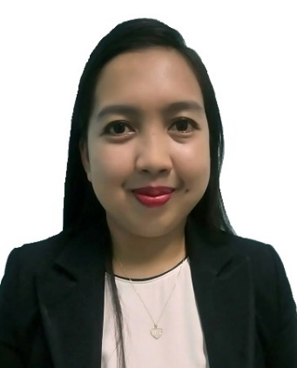
MYLENE
INFOTECH

Email: mylene.368769@2freemail.com
Dubai, UAE

Objective
A dynamic career that allows me to apply my knowledge, skills and values from formal education to the world of professionalism for the interest and advantage of the company.

Skills
Intermediate Troubleshooting/Repair and Installation in network cabling,
Computer hardware and Software.
Basic OS Windows 7, 8 and 10 Installation.
Basic configuration for MS Outlook client computer
Excellent verbal/written communication skills in ENGLISH
Expertise in MS Office tools like: MS Word, Excel and Powerpoint Presentation.
Customer service Experience
Flexible in Work Schedule

Work Experience
Far East Noble House, INC. – Gaisano Grand Mall Davao City, Philippines
INFOTECH
02.2015-04.2017

Information technology branched head for 2 years responsible for processing the Start of Day and End of Day process to produce the total sales of the Company Branch. Making sure that price change is correctly implemented and monitored after End of Day process. Schedule maintenance and repair to Point of Sale machines used by the company for Sale transaction which I implemented since the start of my term. I also make sure that maintenance and repair to IBM/Toshiba printers used in POS Machines and department offices computers and printers were properly implemented within schedule. Giving feedback and printing everyday reports on Front View and EC Pay Bills System used by the company is securely confidential. Fast troubleshooting to network cables for Point of Sale (POS) machines and Department offices are strictly complied with high importance. Setting up new Point of Sale (POS) Machines and connect them to the server host through folder mapping was correctly configured. Tracing Sales Transactions for re checking purposes. Making sure that the associate users of POS machines are well monitored and have the right access to discounting of displayed products. Assemble offline counters for special events in the company which I experience setting up all by myself. Responsible for the finger print registration of newly hired employees, transfer/back-up of registration, delete terminated employees. Educating the newly hired cashiers and lead cashiers about the policies in using the POS machines which was not mentioned during company orientation as well as giving an intensive training my co-IT staff in the department also lies in my position.

TELEPERFORMANCE BPO Company Davao City, Philippines
Expedia Account Sales Agent
12.2014-01.2015

Making Hotel Reservations all around the United States of America using Voyager System and making sure that the information given by the customer is securely confidential and will only be use for reservation purposes. Since the customer also ask for directions going to the preferred hotel I help them get the right direction through Google Maps and find shortest routes for customers pre-destination which I received a lot of recommendation from our senior supervisor and customer. I look for hotels that fit to the customer’s preferences and budget for their planned trip or vacation. I also make sure that the details of the hotels that I booked were emailed to the rightful customer since I always re check the details before submitting the booking details. . I received my EXPEDIA.COM TELESALES Training certificate after completing one month training and various examination.

Department of Science and Technology Region XI Davao City, Philippines
DOST Text Blast System Assistant Programmer (OJT)
04.2014 – 08.2014

Redesigned the already existing system for a better Graphical Interface to the user. Reprogrammed some of the system’s function to be used in different situations. I also take calls regarding the office transactions and scheduled meeting since the office I was assigned to takes local projects mostly about organic food samples.

Education
University Of Mindanao – Bachelor of Science in Information Technology
08.2010 – 10.2014

I was a 1st Placer in Oral Communication English 201 examination last March 2013 held in our Speech Clinic DPT Building University of Mindanao Main Campus. I was also a participant for Extemporaneous and a 3RD Placer for Oration Competition representing our College of Computing Education Department during Intramural (2013-2014) in the University of Mindanao, Main Campus Davao City, Philippines.

Certification
National Certificate II – Computer Hardware Servicing
14110202008751
March 12, 2014

Microsoft Technology Associate 98-366 Networking Fundamentals
F034-5982
October 22, 2014

Training

Participant/Speaker
Mindanao Conference for Information Technology Educators (MCITE)
Ateneo de Davao University Conference Room, Davao City, Philippines
November 17, 2014

Participant/Speaker
Library Conference: A Meeting of Minds, a Festival of Papers
University of Mindanao Learning Information Center, Davao City, Philippines
November 21, 2014

Sales Agent
EXPEDIA.COM LODGING TELESALES Training
Teleperformance, Davao City, Philippines
January 10, 2015

Personal Information

Age : 23
Date of Birth : January 11, 1994
Place of Birth : Digos City, Davao Del Sur, Philippines
Height : 5’2
Weight : 55 kg
Citizenship : Filipino
Status : Single
Visa Status : Visit Visa

