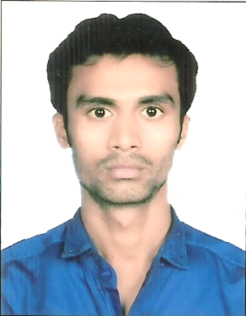
Curriculum Vitae

RIZWANULLAH

RIZWANULLAH.368806@2freemail.com

Presently Working:
- Working in Emirates Flight Catering, Dubai (UAE) as for General Assistant in Linenecraft-1 (Finishing Section) Since May 2015.

Typing & Language known:
- English, Hindi, Urdu, Arabic & Bengali

Educational Qualification:
- 10thPassed From Bihar Board, Patna
- 12thPassed (Intermediate) From Bihar Board, Patna

Technical Courses & knowledge:
- 6 Months Course in Basic Software and Graphic Designing completed from IDREAMS INFOTECH (Chennai)
- Basic computer package (ERP system, Ms-Windows, Word, Excel, Power point, internet & E-mail)
- Awarded in Food Safety in Catering from High field

Technical knowledge & experiences:
- Well knowledge and experiences in Official documentary works in M.S Office and supportive softwares, outdoor & indoor media advertising jobs. Expert in creating the design for hoardings, flex banner signage, paper designing works, E-mail, Scanning and all jobs related to printing department.
- Well knowledge and experiences in Official jobs (Admin), Ms-office, ERP system & Graphic designing.

Working experinces:
- March 2009 to January 2012 Worked in Metro Publicity, Kolkata as for Graphic Designer.
- March 2012 to July 2012 Worked in SR Digital, Mumbai as for Graphic Designer & admin office
- August 2012 to April 2015 Worked in , Rampion Advertising Consultancy & Pvt. Ltd. Darbhanga (Bihar) as for Graphic Designer and official works also. (Clerical)

Strength:
- I am honest, self-motivated and hardworking with positive attitude.

