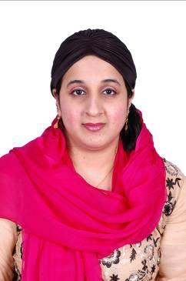
Isra (M.D)
Email ID: isra.368839@2freemail.com
Career Objective
To be a part of dynamic and progressive organization, that offers challenging working envoirment where one can utilize energies and competences in a positive direction and contribute towards overall objectives of organization.

I am willing to work as a:-

- Medical coder(CPC certified)
Career Summary
- Worked as representative for awareness campaigns(dengue,AIDS,vaccination)
- Two years of experience in diagonsing the disease and providing best medical help in a private clinic.(As a GP)
- CPC certification(cleared the exam)

Personal Qualities
- Dealing with patient complaints about the quality of service of the practice.
- Excellent communication skills in written and verbal both.
- Able to lead and motivate staff.
- Ability to prioritize work loads during busy periods.
- Controlling multiple projects at the same time.
Key Responsibilities Handled
- Responsible for accident and emergency (A&E) medical treatment in my academic year.
- Dealing sympathetically with sensitive circumstances.
- Keeping up to date with the latest treatments, medicines and medical developments.
- Provided care to patients on hospital wards, outpatient clinics and also doctors surgeries during my academic year.
- Assisted in the operating theaters in surgical operations during my academic year.
- Worked in a pressurized environment and produce the best result during my academic year.
.
Technical Skills
- Well versed with the basic use of computer.
- Familiar with all the surgical &medical equipment
- Internet savvy.
Achievements
- Received best student certificate in 2011
- Give many speeches for general precautions in many villages.
- Provide free medical help to many poor people in villages during camps.
Academia
- MD (Doctor of medicine) equivalent to MBBS session:-2005-2011
Institute:-Karaganda state medical university
Country:-Kazakhstan
- CPC certification(ICD-10) session:-2017
Institiute :-Dhafir institute
Country:-U.A.E

- HSSC session:-2003-2005
Institute:-Sheikh khalifa bin zayed arab Pakistani school
Major:-Pre medical
Country:-U.AE

- SSC session;-2001-2003
Institute:-Islamia English school
Major:-Science
Country:-U.A.E

Personal Details
Languages Known: Hindi,Urdu,Russian, English,Arabic.
DOB: 01 /01/1988

