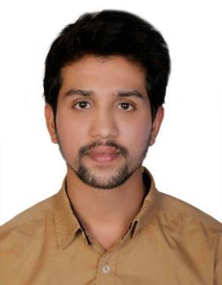
MOHAMMED Assistant Pharmacist (DHA PASSED)

E-Mail: mohammed.368843@2freemail.com

Deira, Dubai (UAE).

AIMS AND OBJECTIVES:

Self-motivated professional with Pharmacy Certificate and Four years of experience seeks to apply medication knowledge for patient health while providing top-notch pharmacy services in retail as well as hospital/clinic setting. Outstanding interpersonal skills with a track record of establishing positive relationships with customers, pharmaceutical representatives/manufacturers, medical professionals, healthcare organizations and insurance providers.

PROFESSIONAL EDUCATIONAL:

D.PHARM (DIPLOMA IN PHARMACY) National College of Pharmacy, Shimoga,Karnataka,India 2011-13

PROFESSIONAL LISENCES:

Pharmacist: Drug Control Department of Karnataka, India

Assistant Pharmacist: Dubai Health Authority (DHA) Exam Passed

PROFESSIONAL EXPERIENCE:

Assistant Pharmacist: Zanbaq Al Madina Pharmacy, Abu Dhabi, UAE 01-11-2015 to till date.

JOB DESCRIPTION:

- Accurately dispensing drugs to patients according to a doctor’s prescription.

- Patient counseling to educate them about side effects, drug interactions and resolve medication delivery problems.

- Dispensing OTC medicines according to patient’s requirements and health condition.

- Taking Insurance approvals and dispensing medicines accordingly.

- Coordinating with Insurance companies and accounts department about approvals, and payments issues.

- Maintaining all Pharmacy documentation, packaging, labeling and recording medications issued to patients.

- Coordinating with all Pharmacy members to work as a team.

- Maintaining pharmaceutical stock, creating inventories and ordering drugs.

Hospital Pharmacist: KMC Hospital Manipal, Karnataka, India | 25-08-2013 to 12-10-2015

- Perform duties according to various procedures and protocol for GDP (Good dispensing practice )

- Execute daily operations of medicine procurement, maintaining stock balance and proper documentation related to patient files and pharmacy inventory.

- Dispensing OTC medicines according to patient’s requirements and health condition.

- Maintain established procedures concerning quality assurance, storage of medicine and security of controlled substances and disposal hazardous waste drugs.

- Provides drug related information to doctors, hospital staff and patients.

- Communicating with customers sympathetically and supportively.

- Coordinating with all Pharmacy members to work as a team.

- Maintaining pharmaceutical stock, creating inventories and ordering drugs.

KEY SKILLS AND COMPETENCIES:

- Good interpersonal and communication skills.

- Drug knowledge and assessment.

- Ability to inspire the trust of others.

- Strong organizing and management skills.

- Basic knowledge of MS Office, Pharmacy Plus, EZE-POS,CLINC PRO, OPENJET, ECLAIM, PBM & various internet tools and software.

- Awarded with Best employee of the year- 2016 at MESK AL MADINA MEDICAL CENTER &

PHARMACY.

PERSONAL DETAILS:

FULL NAME

MOHAMMED

Date of birth

8th Sept 1993

Religion

Islam

Marital status

Single

LANGUAGES KNOWN

FLUENT: English, Hindi, Urdu, Kannada, Malayalam,

VISA STATUS

UAE Resident Visa.

