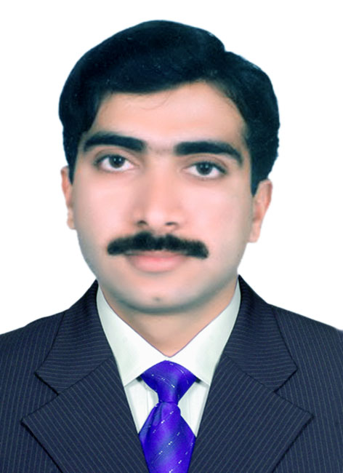
Muhammad
Email: Muhammad.368877@2freemail.com

Career Objective

Seeking a career in the field of ‘INFORMATION TECHNOLOGY’ ‘TELECOM & MEDIA’ in an organized and professional environment so that my skills can put forward more expelled performances. I am keen to meet the competitive industry requirements through a result oriented approach and the practical potential.

Work Summary

   Thorough knowledge of:

- Virtualization ESX/ESXi 3.x/4.x/5.0, Virtual Center Server / vCenter Server, VMware View, VMware Workstation, VMware vCenter heartbeat, Hyper-V
- Storage Dell EMC Clarion CX-Series, NAS Storage
- Installing networks maintenance and troubleshooting. CCTV Installation, Setup, Troubleshooting, Backup.
- Providing Network Setups, Installation, maintenance & Troubleshooting Services to Major IT Organizations Installing Wi-Fi System using Access Point in Firms.
- Software Installations troubleshooting, virus removal, rectification o Operating System installation, and maintenance, Linux, Windows Server. o Virtual Private Network.
- Expertise in data recoveries
- Assembling hardware & new Computer Systems o Software & Hardware Solutions.

Computer Network Support
Technical Support Engineer. Self Employed.
Providing tech support to private banks and other institutions.

5June 2013-----to Date Scope of Job:

  - Virtualization ESX/ESXi 3.x/4.x/5.0, Virtual Center Server / vCenter Server, VMware View, VMware Workstation, VMware vCenter heartbeat, Microsoft Hyper-V.
  - Storage Dell EMC Clarion CX-Series, NAS Storage
Backup VMware Data Recovery, VMware Consolidated Backup, Symantec Backup Exec

  - Configuration of Routers, Switches and Access Points.

  - Server Support Windows Server 2008 and windows server 2012.

  - Data Base server management and Backup.

  - VPN management configuration.
  - Configuration and installation of firewall Fortigate 200A and 60B / WatchGuard and Cisco ASA.
  - Lost data Recovery from Physical / Virtual Hard Drives.

Network Administrator / IT Procurment Administrator

Supreme Foodservice FZE, Silicon Oasis Dubai, UAE

Head Office - Turbinenweg 2, 8866 Ziegelbruecke, Switzerland

10-AUG-08 --------- 19-03-2013

Scope of Job:

  - Virtualization ESX/ESXi 3.x/4.x/5.0, vCenter Server, VMware View, VMware Workstation, VMware vCenter heartbeat, Hyper-V
  - Storage Dell EMC Clariion CX-Series, NAS Storage
Backup VMware Data Recovery, VMware Consolidated Backup, Symantec Backup Exec.
  - Administrate Support and Troubleshooting Networks.

  - Troubleshoot & Installation the Desktops, Notebooks, and Servers.

  - Solution for Hardware problems, software problems.

  - FTP server and User management.

  - Look after Exchange Server.

  - Configuring Cisco Routers, Switches and Access Points.

  - Backups Using NAS and Tape Drive.

  - Server Support Windows Server 2003 and windows server 2008.

  - Data Base server management and Backup.

  - Virtual Private Network management configuration.

  - Microsoft AX beginner support.

  - Using WebEx for online meetings.

  - Using Microsoft Share Point to manage User Troubleshooting.

  - User technical Support Windows XP Pro and Windows Vista Business.

  - Citrix Starter Support and installation.

  - Configuration of Cisco Routers, Switches and Access Points.

  - Server Support Windows Server 2003 and windows server 2008.

  - Data Base server management and Backup.

  - Virtual Private Network management configuration.

  - Microsoft AX beginner support.

  - Citrix Support.

IT Support

Supreme Foodservice GmbH & Co. KG, UAE
5-May-08----- 10-Aug-2008

Scope of Job:

- Support and Troubleshooting Networks.

- Troubleshoot the Desktops, Notebooks, and Servers.

- Look after the DSL connectivity.

- Maintaining Exchange Server.

- Backups Using NAS and Tape Drive.

- Data Base server management and Backup.

- Virtual Private Network management configuration.

IT Officer

Bank Alfalah Limited Pakistan
(Feb 2007 – Mar-2008)

Scope of Job:

- Administration of Branch Network
- Look after Online Connectivity with all country branches
- Managing SQL Server
- Manage DXX and ISDN Link
- Branch Computers maintenance
- Video Security of Bank
- Managing Q-Metic system (the queue system)
- Managing Bio matrix system of branch.
- Managing VSAT Connectivity.
- Installing new system with bank’s software.
- Troubleshooting the software errors and problems.

- CCTV Backup. Installation, Troubleshooting etc
- Troubleshooting the Professional Printers, Scanners and other peripherals.
- Troubleshooting & Manage ATM Machine (NCR).
- Troubleshooting & Manage Access Points.
- Troubleshooting & Manage Wireless Router.

Assistant Accounts Officer / LAB Admin

Muslim Computers (Pakistan)
(Mar 2000 – September 2004)

Work Profile:

- Teaching the Networking and the Internet.
- Maintaining Whole Lab of Organization.
- Administration of Computer Networks in the organization.
- Provide Network Troubleshooting Services to other Organizations.
- Installing WiFi System for Customers.
- Installing Operating System windows, Linux, Windows Server etc.
- Assembling new systems.
- Hardware Solutions.
- Manage Accounts.
Professional Skills

o Time Management – Work under tremendous work pressure & met with dead-lines with ease and efficiency. o Good personal relations, communications and coordination skills.
o Training colleagues having customer contact.

Educational Qualification

o BS (Computer Science) from Allam Iqbal Open University, Islamabad, Pakistan in the year 2006 o HSCC (Computer Science): from BISE, Dera Ghazi Khan, Pakistan in the year 2002.

o S,S.C. (Math, Physics) from BISE, Dera Ghazi Khan, Pakistan in the year 1999.

Certifications / Diplomas

- Diploma of Optical Fiber & Cable Joining from Pakistan Telecommunication Limited (PTCL) Pakistan, Islamabad, Pakistan in the year 2006

O | CCNA Preparation CCNA Test preparation from CORVIT Lahore, Pakistan. In the year 2006
Trainings / Workshop / Seminars / Conference
O | Network Administrator / IT from Bank Alfalah Training Centre, Lahore, Pakistan in the year 2006.
O | Intel Channel Conference 2006 Attended the Intel Channel Conference 2006 at Holiday Inn, Multan, Pakistan
 | Organized by Intel Corporation, USA.
O | Intel Channel Conference 2007 Attended the Intel Channel Conference 2007 at Holiday Inn, Multan, Pakistan
 | Organized by Intel Corporation, USA.
Languages Skills
 | o | Speaking & writing fluent English
 | o | Speaking &writing fluent Urdu/ Hindi
 | o | Speaking fluent Punjabi
 | o | Speaking fluent Seraiki
Personal Details
 | Date of Birth: |  | December 25, 1982
 | Nationality: |  | Pakistani
 | Marital status: |  | Married
 | Religion |  | Islam
 | Expiry |  | 4th August 2025
 | Driving License |  | Valid Pakistani Driving License
 | Driving License 2nd |  | Valid UAE Driving License
PERSONAL TRAITS

Workaholic, Team motivator, Result Oriented, Humble and Polite.
INTERESTS
Net surfing and travelling.
References

Reliable references available if require

