CURRICULUM VITAE::
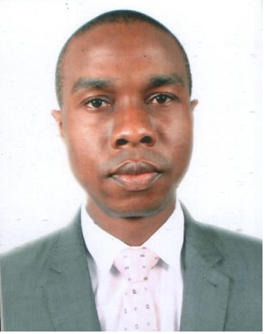

NAME: Onwugharam
Onwugharam.368878@2freemail.com

PROFESSIONAL HIGHLIGHTS
6years experience in customer service environment.
Competent in acting as a liason between customers and service manager.
Highly skilled in performing follow up and back up work duties.
In depth knowledge of account documentation and review.

EDUCATION QUALIFICATION
Higher National Diploma (HND) computer science with DISTINCTION from Lagos City Polytechnic in 2015, Lagos Nigeria.

Ordinary National Diploma (OND) computer science from Lagos State Polytechnic in 2010 Lagos, Nigeria.
PROFESSIONAL EXPOSURE
From: May 2011--Feb. 2017
Position: Teller / customer service Representative
Company Diamond Bank Plc, Nigeria.
JOB RESPONSIBILITIES
- Provide first point of contact for customers.
- Cheque/cash encashment/ deposit.
- Answer customers questions and resolve issues appropriately.
- Issuance managers cheques, processing of other banks cheques(O.B.C).
- Issuance of personal travel allowance(P.T.A.),business travel allowance(B.T.A).
- Prepare teller proof,Atm proof/cash.
- Payment of western union,money gramm,telegraphic transfer.
- Manage automated funds transfer (AFTs)
- listen to customer by providing high quality service.
- Deals and resolves customers’ complaints and criticisms in a professional manner.
- Cross sell and up sell company's products.
- And other duties as may be directed by the organization.

From Sept 2008 – March 2010
Position: Waiter
Company: Rita Lori Hotel Nigeria

JOB RESPONSIBILITIES
- Provide Excellence customer service that promote satisfaction.
- Greet Customers and present menu.
- Make recommendations and sharing additional information upon request.
- Check on customer to ensure they are enjoying their meal.
- Take and serve food/drinks order and up-sell any additional products.
- Liaise with the kitchen staff to ensure customer’s orders are prompt.

From June 2006 – June 2007
Position: Senior Waiter
Company: Choicest fast Food And restaurant

JOB RESPONSIBILITIES
- Take order from customers for food and beverages.
- Clean and tidy the lobby.
- Check product for quality and correct any problem.
- Follow all relevant health department rules and regulations, and all customer service guidelines.

SKILLS
Excellent client service interpersonal and communication skills.
Ability to manage one task simultaneously.
Good listener, good team player and self motivated.
Established ability to use tact and diplomacy when needed.
Quick in grasping of new concept.
Good knowledge of bank policies and products.
Computer literate.

OTHER CERTIFICATES:
2015 Project on deploying of cloud service for Networking Lagos city polytechnic, Nigeria

2011 Teller service Representative orientation Programme JMJ Consulting Nigeria

2010 Project on design and implementation of file
Encryption and decryption system Lagos state Polytechnic, Nigeria

2005 Customer Service Training J.A Ogwu (MILR), Nigeria

I. T SKILLS:

Windows and office tools
Computer language Basic

Operating system, networking, hardware and applications
Computer science Basic

LANGUAGE
Proficiency in English, Yoruba and Igbo

