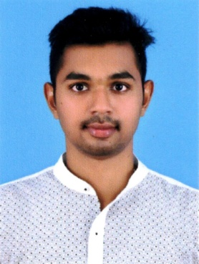

MANEESH

Maneesh368888@2freemail.com

Dubai, UAE.

Objective
Seeking a career to utilize my knowledge, personal skills to gain comprehensive understanding of a reputed organization so as to take responsibility and contribute significantly.

Education

2015 – 2016: MBA (HR & MARKETTING) FROM BANGALORE UNIVERSITY, KARNATAKA, INDIA.

2011 – 2014: BBm (bachelor of business management) FROM manav bharati university, HIMACHAL PRADESH, INDIA

2010 – 2012: PLUS TWO (12TH) cOMMERCE FROM CBSE BOARD, INDIA

2009: 10TH FROM CBSE BOARD, INDIA

Experience

hr executive ~ koTak mahindra bank, bangalore, india

(aug- 2016 to nov-2016)
Taking care of Joining formalities of the Employees, Co-ordination with the new joinnies of the internal employee, issuing the Offer Letter and explain the salary details, Employee Relationship, PMS System of the Employee and Processing Employee Mediclaim & Other Employment Registration forms.

Academic Projects Undertaken

Company: sree ganesh industries, Kerala, india.
(INDUSTRY: MANUFACTURING)
Resource allocation of funds: I was analyzing resources of funds and for that I have to work with the finance department.
A case study: Linkage between labor welfare measures and employees job satisfaction. (SREE GANESH INDUSTRIES)

A study on the impact of social media on social security with reference to Bangalore City

IT Credentials:
- Proficient in working on MS Office (windows XP, Windows 2007, 2010, etc)
- Two month course in DTP from One Zero Computers

Skills Set:
- Strong problem solving skill to resolve issue quickly and fairly.
- Excellent presentation skill.
- Ability to deal with people.
- Willingness to learn.
- Good analytical skill.

Achievements:
- Participated in "Cancer Awareness Walkathon 2015, Bangalore"
- Participated in the student conclave 2016 on the theme "Dissertation Guidelines - Ideation to Execution"

Hobbies & Interests:
- Traveling (long drives).
- Music, Movies, Sports Events, etc
- Playing Badminton & Volleyball.

Personal Details:

Nationality : Indian
Gender : Male
Marital Status : Single
Visa Status : Visit Visa
Languages know : English, Hindi, Malayalam, Tamil, and Kannada.

Declaration:

I hereby declare that the above furnished details are true with proven records.

Date:

Dubai, UAE Maneesh

