Dr AAISHA

DOB: 15/01/1990
NATIONALITY: INDIAN
RELIGION: ISLAM
Email: aaisha.368930@2freemail.com

About
Empathy is one of the important factor within me which has driven me towards healthcare profession and thus I studied Bachelor of Homoeopathic Medicine and Surgery (B. H. M. S.) including one year internship followed by PGDM in Healthcare Management
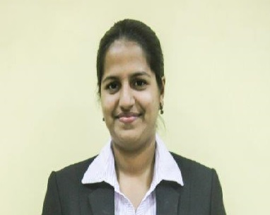
This course has given me immense happiness by serving needy people. I am looking forward to work with an organization which is dealing with providing affordable health solutions and improvising the health status.
I assure my sincere and hardworking efforts in the completion of tasks with positive approach.

Summer Internship
- Two months internship in SEARCH (Society for education, action and research in community Health), Gadchiroli, Maharashtra.
- Worked with tribal health department. Prepared an analytical report comprising of 13 years data of “Arogya Sansad” (annual tribal meeting)

Academic Qualification
Exam / Degree | Board / University | Year | Percentage/CQPI
PGP - II | Goa Institute of Management | 2014-2015 | 6.5
PGP – I | Goa Institute of Management | 2013-14 | 5.61
B.H.M.S | Goa University | 2011 | 65%
H.S.S.C | Goa University | 2007 | 66%
S.S.C | Goa University | 2005 | 81%

Projects Undertaken
- Homoeopathic Approach in Treatment of Peripheral Vascular Disease
- Project on Streamlining Admission and Discharge process for Goa Medical College
- Project on Alcoholic Liver Disease
- Consumer Behaviour study
- Feasibility study of clinical services expansion at Sangath
- Give Goa initiative – X Joint Conference of ISMOCD & IAE

Extra-curricular achievements
- Participated in CURIOUS-2014 case study competition at Indira Institute of Management, Pune. Shortlisted in top 10 competitors.
- Attended Medical First Respondent course organized by St. John Ambulance Association Goa
- Attended the First All India Student Parliament on Health in 2003
- Hobbies: Cooking, Dancing and Travelling.

Computer Skills
- Proficiency in MS OFFICE package (MS WORD, MS EXCEL, MS POWERPOINT)

Work Experience
- Working as Assistant Manager – Underwriting in Bajaj Allianz Life Insurance Company since 2015
- Job Profile involves assessing Medical and Financial profile of Individuals and taking decision to issue or reject policies in Software OPUS
- Based on Medical Eligibility Postponing or Declining policies
- Identifying Fraud cases and sending for Live Verification
- Imparting Medical Training

