Resume
Bhagirath 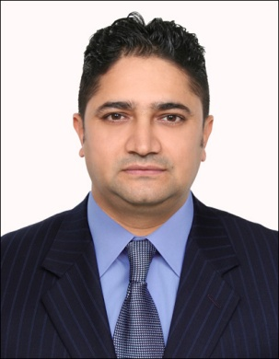
Dubai, UAE
Email: bhagirath.368933@2freemail.com
Objective :-
- Seeking for a high class establishment where my experience and skill’s will be utilized.
- Seeking for a long term job as per my experience&effort.
Skill’s
- Able to make cost report
- Able to make Cost effective Menu.
- Able to understand all investment regarding to cooking and kitchen.
- Good communication and writing skill’s.
- Able to work independently and under pressure.
- Able to follow all recipes and menu’s.
- Able to handle kitchen& Banquet
- Able to handle more than 5o staff.

Work Summary :-
- Working as a Chef De Prtie (Wok Section) at Bazxar Restaurant DIFC,DUBAI UAE since 25th May 2016 to till now.

- Worked at Y&Y PUBLISHING MEDIA CITY,since Nov 5th 2014 to 20th May 2016as a Sales.

- Worked as Executive Chef, at Atmosphere Restaurant & Lounge Hathisar, Kathmandu since 1St Nov 2013to 31st October 2014.

- Worked at Factory Restaurant&Bar,Thamel as a “Executive chef” since Jan 27th 2012 to 15th Oct 2013.

- Worked at “THAI EXPRESS” as a “Thai Chef” from Dec13th 2010 to Nov 30th 2011.
- Training at Dubai Thai express since 4th Nov 2010 to 25th Nov 2010
- “Maggiano’s Little Italy” From Brinker International (USA), Under Jawad Business Group (KSA). Worked as “Sou Chef” Since 1st oct2009 to 1st Nov 2010.
- Worked as a “Chef De partie” at “Hyatt Regency Hotel, Taragaun, Boudha, Khatmandu Nepal. Since 1st Nov 2007 to 30th Aug 2009.
- Worked as a “Head Chef” at 1905 Restaurant & Bar Kantipath, Kathmandu, Nepal. Since 1st Jan 2006 to 1st Oct 2007.
- Worked as a Commi-I at “Royal Singi Hotel”, Laldurbar, Kamaladi, Kathmandu, Nepal Since Dec 10th 2003 to 20th Dec 2005.
- Worked as a Commi-ii at “The bakery Cafe” Durbarmargh, Kathmandu Nepal. Since 13th Sep 2001 to 17th Oct 2003.
- Worked as a Kitchen helper at “Dalima Resort” Kurintar, Chitwan, Nepal. Since 1998 1st June 1998 – 15th Aug 2001.
- Training At “Raman manpower Training Center”,Thamel. kathmandu Since 1st Feb to 1st May 1998.

Qualification&Training
- S. L. C Passed from Adarasha Ma. Vidhyalaya. Kathmandu, Nepal.
- Intermediate From Pashupati Multiple Campus. Chabhil Kathmandu Nepal.
- Hygine Training from Jawad business group at Saudi Arabia.
- Thai cusine Training from Dubai.
- Computer courses Aptech computer training centre, Kathmandu.
Personal Details:-
Date of Birth : 01 January 1976.
Sex : Male.
Nationality : Nepal.
Marital Status : Married.
Language Known : English, Hindi & Nepali, Arabic
Hobby : Cooking &Management
General:-
- Dedicated co-operative and hard working.
- Ability to adopt to any job situation and handle it effectively.
- Good initiative and interpersonal communication skill.
- Well appreciated by management and associates.

