JUNAID

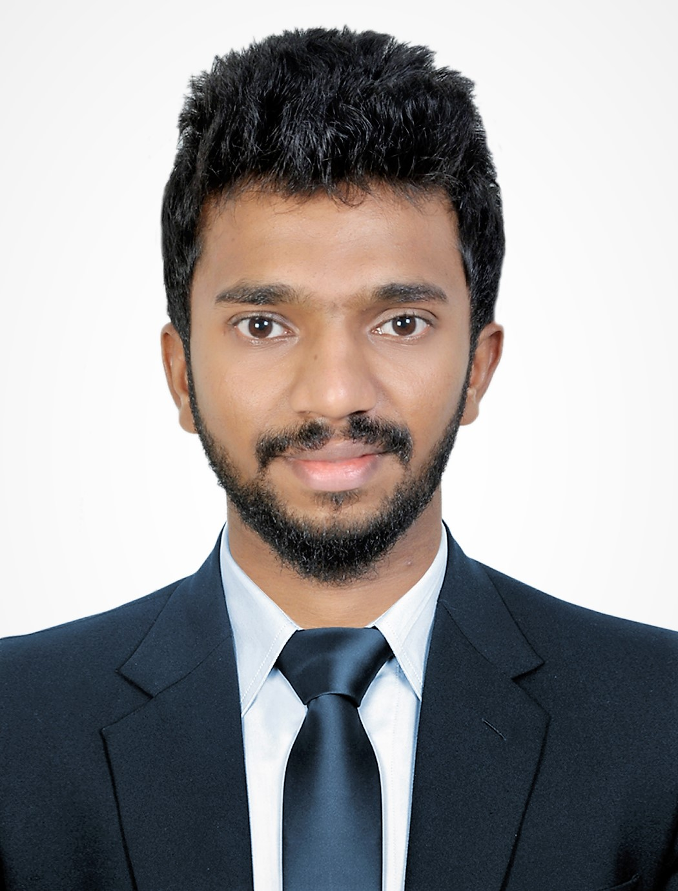
  - JUNAID
Email: junaid.368945@2freemail.com

  - Personal Details
Date of birth: 12-3-91
Nationality: Indian
Gender: Male
Marital Status: Single
Religion: Islam

  - Visa Details
Visa status: Visiting Visa

Computer Skills

Microsoft Word
Microsoft Excel
Microsoft Office

  - Languages
English
Hindi
Malayalam
Tamil

  - CARRIER OBJECTIVE
To work in high engineering & skilled environment with positive attitude, seeking assignments in Project management / Networking / Telecom with an organization of repute in the Telecom sector, to hold a position of responsibility in an organization with an opportunity of growth of the organization along with having a long-term relationship and to conduct myself in such a manner so as to uphold the dignity of profession.

  - SKILLS
- Ability to work in an independent environment with minimum supervision and full accountability.
- Undertakes radio network planning for all sites in the concerned area, while fulfilling its coverage requirement with minimum/zero interference.
- Conducts KPIs analysis & implementation for 3G/LTE, UMTS, CDMA and GSM network.
- Responsible for troubleshooting and optimization for network, change parameters in order to improve the KPIs.
- Conducts drive tests analysis and prepares reports for the same.
- Surveys and identifies new sites as per coverage and capacity requirement.
TRAINING & CERTIFICATE
ZTE CERTIFIED TELECOM ENGINEER
Trained in some of the leading technologies including GSM/2G, UMTS/3G, LTE/4G, WCDMA, RF Planning, Designing, Optimization, Survey, Drive test tools, Radio Access Networks, Advance Core Networks.

  - EDUCATION
2009-2013 | B.Tech in Electronics and Communication  KMCT College of Engineering-Calicut University  Marks: 65%
2007-2009 | Higher Secondary Education (HSE, Kerala)  MJ Higher Secondary School-Calicut  Marks: 83%
2007 | SSLC (Board of Public Examination, Kerala)  GHSS Sivapuaram-Calicut  Marks: 85%
WORK EXPERIENCE
RF ENGINEER (2016-2017)
RS-SPECTRA SOLUTIONS
Calicut
Major Responsibilities:
- Optimized the GSM and UMTS networks to reducing drops and block and achieve the desired network key performance indexes (KPI).
- Collected, processed and reviewed drive test data. Worked with the operations team to troubleshoot site network problems.
- Diagnosed all RF related problems such as interference, dropped call, SDCCH failure, etc.
- Prepared technical reports for performance of sites per cluster for department executives.
Major Projects:
Vodafone Project
Duration: Oct 16 to Dec 16
Circle: Kerala
Tools Worked Upon:
- TEMS INVESTIGATION
- Map Info Professional
- ATTOL
ACADEMIC PROJECT
Ensuring data storage security on cloud computing
In this project, we focus on cloud data security, which has always been an important aspect of quality of service. To ensure the correctness of user’s data in the cloud, we propose an effective and flexible distributed scheme with two salient features, opposing to it’s predecessors.
ACHEIVEMENTS
- Presented seminar on “MICROWAVE FILTER AND PATCH ANTENNA”.
- Participate on various IEEE camps.
- Coordinator of KARMA2013 (Arts Festival).

DECLARATION
I hereby declare that the above furnished details are true to the best of my knowledge and belief.
JUNAID

