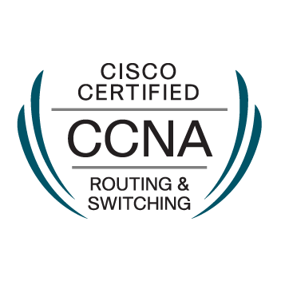
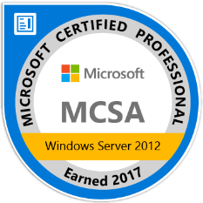
RESUME

SADHAM
SADHAM.368955@2freemail.com
___________________________________________________________________________

OBJECTIVE
To obtain a position of IT Admin with tech where I can utilize my System Administration, software, hardware and troubleshooting experience in order to provide the company with a solid support system.

SUMMARY OF QUALIFICATIONS

- Highly skilled in providing support and monitoring a business’s core IT resources
- Managing, Troubleshooting and repairing of Servers, Desktops, Laptops and Thinclients
- Managing CCTV Surveillance, Digital Attendance system and Bio Metric systems
- Five years and Six Months of extensive technical experience in IT industry
- In depth knowledge of providing troubleshooting services for both software and hardware issues
- Track record of collaboration with co-workers to achieve maximum efficiency and full system functionality
- Proficient in driving improvements in technology and relates procedures

PRIMARY SKILLS

- Active Directory, Server Management and Data Backup
- Routing and Switching
- Hyper-V and Virtualization
- Windows / Mac Operating System Installation and Configuration
- Remote Support using Microsoft™ RDP, Teamviewer, Dameware Remote control
- Troubleshoot Windows(XP/7/8/8.1/10), Windows Server(2003/2008/2012/2016) and Mac-OS
- Mail Server Installation, Configuration and Management (POP/IMAP/Exchange Server/Google Mail Admin)
- Windows™ Products and Other Products installation, configuring and update
- Troubleshoot Windows(Desktops, Laptops and Tablets),Android(Tablets and Mobiles) and Mac™ Products (iPhone, iPad, iMac and MacBook)
- Provide E-Mail, Chat and Telephonic Support
- Creating Corporate Network environment(Cabling, Switching, Routing and VPN)
- File, Database Backup and Restore using NAS, Cloud and Tape
- Managing Network and Local Printers and Troubleshooting
- Administrating NAS, SAS, Tapes and Cloud storage
- Nortel, Avaya and Cisco VoIP Telephone Management
- Web Monitoring, Network Monitoring and Server Performance Monitoring)
- Single Sign on, Windows Deployment and Server Automated Scripting

CERTIFICATIONS

- CCNA – Cisco Certified Network Associate
- MCSA – Microsoft Certified Solutions Associate

EXPERIENCE

Neocasa Interiors LLC-Dubai, U.A.E.
IT Admin (05 Jan 2015 to 06 Feb 2017)

- Configuring and managing of Servers, Desktops, Laptops, POS and Mac Devices
- Administrate MS Active Directory, Accounts, GPO and File Sharing Management
- Routers and Switching Management
- Managing CCTV Storage and Biometric attendance system
- Maintaining web & Email server and Website updates
- Configure Microsoft outlook and Troubleshooting their issues
- Maintaining the telephone and mobile phone connections, bills and services
- Install, configuration and troubleshooting of OS, software’s on desktop and laptop
- Manage and configure network devices and monitor the network traffic and VPN
- Install, Configure and Troubleshoot local and network printers
- Provide Telephonic and Remote Support
- Ensure proper working order of all terminals and servers at all times

Wipro Infotech-Chennai, India.
Desktop Support Engineer (05 June 2013 to 22 Nov 2014)

- Install and maintain hardware and software components and VDI terminals
- Managing CCTV Storage and Biometric attendance system and Troubleshooting
- Configure Microsoft outlook and Troubleshooting their issues
- Manage incident resolutions in the Help Desk tool.
- Install and configure software updates on desktop and VDI terminals.
- Update and Manage antivirus database and Manage Antivirus Management Client
- Manage and configure network devices and monitor the IP details
- Install, Configure and Troubleshoot local and network printers
- Remote System troubleshooting(Using MSTSC,DameWare,Teamviewer,GoToAssist)
- Provide Telephonic, E-Mail and Remote Support

Sans Computers - Pattukkottai, India.
Desktop Support Engineer (25 May 2011 to 24 May 2013)

- Managing customers with their issues on PCs, Laptop, Printers, network and servers
- Provide technical supports, troubleshooting, installation and site visits on need basis
- Installing of OS, Repairing Printers, Networking and server installations
- Interacted with customers into support software and hardware problems and updates
- Virus Cleaning, repair Corrupted OS and Repairing PC, Laptop, Printers and POS
- Assembling new PC, new server and creating Server-Client environment

EDUCATION

- BSc in Information Technology | 79.5%
Enathi Rajappa Arts and Science College – 2011, Pattukkottai, India
- HSC in Computer Science | 82.8%
Government Boys Higher Secondary School – 2008, Pattukkottai, India
- SSLC in State Board | 68%
Government High School – 2006, Pattukkottai, India

PERSONAL DETAILS

Hobbies
- Fishing,
- Social Networking
- Tech Forums (Google Forums, Gsmarena and Microsoft Insider)
- Sports – Football, Bicycling and Swimming

Interests
- Social Activities, Charity
- Fishing, Hunting and Travelling
- Travelling – Exploring exotic countries
- Cooking

DECLARATION

I hereby declare that the above furnished information is true to the best of my knowledge.

