_{RESUME}
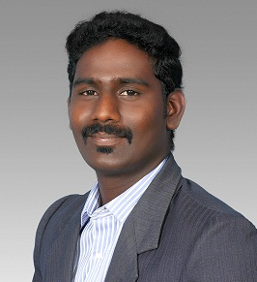

JEEVA B.P.E, M.P.ED,
E-Mail: jeeva.368979@2freemail.com

SUB : Submission of application for the post of
Physical EDUCATION TEACHER.

Respected Sir,
I wish to apply for the post of PHYSICAL DIRECTOR in your esteemed institution. If I am given a chance to serve in your institution, I shall prove my worthiness and work for the improvement of sports activities and overall development of institution and I will discharge my duties to the utmost satisfaction of the authorities. herewith I am enclosing my resume for your kind perusal and favorable consideration.
Thanking you.

Yours sincerely, (JEEVA)

EDUCATIONAL QUALIFICATION

Degrees awarded

2009-2010 : M.P.ED. (Master of Physical Education),
Pondicherry University,
Pondicherry.
2005– 2008 : B.P.E (Bachelor of Physical Education),
Annamalai University, Chidambaram,
Tamil Nadu.
Special qualification
- All India qualified A Grade referee in Ball badminton.
- Till I am the coach of Pondicherry University Ball Badminton (women) team from 2009.
- Till I am the Table Tennis Coach Of School Children From 2010

EXPOSURE

Operation System : M.S office – WORD, EXCEL, POWER POINT, JAVA, V.B.
Areas of special interest

- First aid (Specialization)
- Fitness Trainer (Specialization)
- Ball Badminton(Specialization)
- Table Tennis(Specialization)
- Cricket(Specialization)
- Athletic (Specialization)
- Softball
- khabadi
- Kho-Kho
- Chess
- Volley ball
- Music- keyboard.

ACHIEVEMENTS & OTHER ACTIVITIES

- Winner in cricket inter college tournament in Pondicherry University.
- Winner in senior national’s tournament in ball badminton.
- Runners in cricket inter college tournament in Pondicherry University.
- Runners is table tennis in inter college tournament in Pondicherry university
- Represent inter university tournament in Ball badminton.
- Represented Senior Nationals more times in ball badminton
- Represented in all India inter university table tennis

PERSONAL DETAILS

Date of Birth : 19/08/1987
Sex : Male
Nationality : Indian
Languages : Tamil, English, Malayalam
Marital Status : Married
Experience : 7 years

DECLARATION
I assure that the information and facts stated above are true to the best of my knowledge and belief’s

Place : PONDICHERRY
Date :04/04/2017 Signature ( JEEVA )

