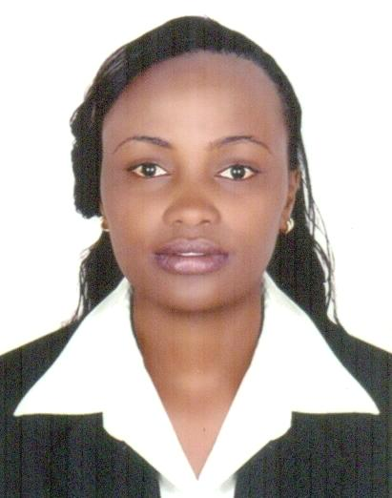
PERSONAL DETAILS
NAME : PAULINE
NATIONALITY : KENYAN
MARITAL STATUS : SINGLE
LANGUAGES : ENGLISH AND SWAHILI
EMAIL : Pauline.369008@2freemail.com

CAREER OBJECTIVE
Seeking a position where my qualification & skills can be highly utilized achieving professional excellence and steady career growth. To be part of a team, contributing, learning and enhancing my developments to achieve new heights in the field of medical health, scientific work and technology and communicate effectively at all levels with ability to work in multi-cultural setting.
WORK EXPERIENCE
Over Two years’ experience in national, provincial, level four and level two hospitals. Highly skilled in phlebotomy, microbiology and hematology departments and good relationship with both clients and members of staff. Well versed in assisting clients, managements of documentations and housekeeping of laboratory. Demonstrate ability to calibrate and troubleshoot equipment .Testing of samples and time management’s skills. Excellent communication skills; both oral and written.
JUNE 2016 -UP-TO DATE CLINIX HEALTH CARE LIMITED (NAIROBI)
POSITION : LABORATORY TECHNOLOGIST
Duties
- Performing in house test received in the laboratory.
- Sampling, testing and analyzing of results in order to produce reliable and precise data to support scientific investigations.
- Recording and sometimes interplating results to present to senior colleague and patients
- Housekeeping of laboratory by ensuring laboratory is well stocked and resourced.
- Ensuring safety procedure is adhered to.
- Coordinating activities with other laboratory sections, other service departments and external customers.
- Performing and reviewed all clinical report for quality
- Assisted with proficiency testing program and preparing, reviews and update procedure manuals.
- Performing instrument maintenance and troubleshooting
- Assisted section staff scheduling and work assignments and provide information for annual personal evaluation.
- Monitoring supply inventory, uses resources efficiently and provided input for cost savings.
- Assisted in evaluation and selection of new or replacement equipment’s.

JULY 2014- MAY 2016 : GLORY LABORATORY AND DIAGNOSTIC
POSITION : LABORATORY TECHNOLOGIST
DUTIES.
- Using, cleaning and maintaining various types of equipment.
- Ensuring that all chemicals were used and stored according to manufactures’ instructions.
- Recording results and sometimes dispatching them to the client.
- calibrations of machines
- Following and ensuring strict safety procedure and safety check.
- Performing quality control.
- Performing blood grouping, and DCT
- Performing and reviewed all clinical report for quality
- Assisted with proficiency testing program and preparing, reviews and update procedure manuals.
- Performing instrument maintenance and troubleshooting
- Assisted section staff scheduling and work assignments and provide information for annual personal evaluation.
- Monitoring supply inventory, uses resources efficiently and provided input for cost savings

EDUCATIONAL BACKGROUND.
2011-June 2014 : Kenya Medical Training College
(Diploma in Medical Laboratory Sciences)
JAN 2011-APRIL2011 : Valentine Computer College
(Certificate of Computer)
2007- 2010 : Karaini Secondary School
(Certificate of Secondary Education (GRADE B MINUS)
PERSONAL PROFILE
- A multi-talented and hardworking individual with rich background of laboratory technology work , research and Information Technology
- Good Interpersonal and Communication skills at all levels
- Fast problem solver, ability to meet deadlines and work beyond time limits
- Highly organized, focused, confident and proactive
- A good team player and can work without supervision.
- Observe work ethics

