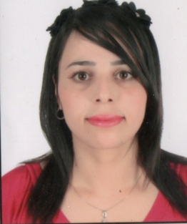
Curriculum Vitae

Name : Zohra
Email : zohra.369062@2freemail.com
Date of Birth : 20 Mar 1985
Languages Known : Arabic, French & English & Spanish.
Nationality : Algerian.

Objective
Looking for a challenging position where by I can utilize my educational and professional experience to substantiate myself in a stimulating field within a professional and a civilized multinational organization.
To build a long-term symbiotic relationship with the organization, contribute effectively towards its growth.

Professional career

PHARMACY ASSISTANT Relizane. Algeria
Pharmacy Assistant Oct 2010 - Oct-2013
- Check for expired medications & notify the pharmacist when stock is low.
- Take in and handle out prescriptions
- Use store’s computer systems to generate label and stock lists
- Order items for use within and outside department
- Receive, load and unload incoming goods from manufacturers, wholesalers and elsewhere
- Answer queries on the availability and supply of medicines.
- Respond to face to face and telephone enquiries
- Pre-pack, assemble and label medicines
- Create and maintain patient profiles
- Prepare insurance claim forms
- Manage the cash register.
RETAIL PHARMACIST –Oran. Algeria
Retail Pharmacist Mar 2014 - Feb-2016
Responsible for the day to day running of the Pharmacy. Providing a professional sympathetic and supportive service to patients and identifying the right healthcare solution to meet their needs.
Duties:
- Accurately dispensing drugs to patients according to a Doctor's prescription.
- Checking prescriptions for errors & making sure they are appropriate for patients.
- Measuring, packaging, labeling and recording medications issued to patients.
- Instructing patients on how to use medications, possible side effects and storage.
- Contacting and working closely with other healthcare professionals.
- Answering questions from patients and staff about medicines.
- Ensuring the accuracy of all prescriptions, products and services supplied.
- Helping to develop the pharmacy's electronic discharge system.
- Talking to regular patients to see how their treatment is going.
- Communicating with customers sympathetically and supportively

Skills

- Good communication and interpersonal skills , good administrative skills
- Problem-solving skills , Flexibility
- Familiarity with computers
- The ability to keep sensitive information confidential
- Willingness to use own initiative
- The ability to remain calm under pressure
- Ability to plan, organize and to work under pressure to tight personal and departmental deadlines;
- Possession of a flexible approach to working alone, or as a member of a team;
- Commitment to outstanding service by the whole department;
- Excellent interpersonal skills and the ability to communication at all levels;

Education

- Diploma Qualification in Pharmacy (2004- 2009 )
University of Djilali Liabes . Algeria

- Algeria drive license.
Hoppies
  - Swimming, Reading, Riding horse

