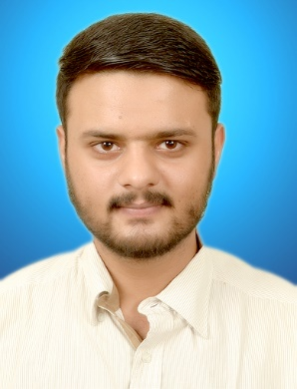
Hunaid
Email ID: hunaid.369066@2freemail.com

PERSONAL INFORMATION
- Nationality: Pakistani
- Marital Status: Single
- Date of Birth: 19th April 1994

OBJECTIVE
To acquire a challenging position in a well-established organization that offers professional growth, can enhance my knowledge in the respective field and enrich my competencies in my profession

EDUCATION
- B.S In software engineering (2016) From ISRA University
- Intermediate from Preston Boys College Hyderabad in the year 2011
- Matric from strong base High School Hyderabad in the year 2009

PROFESSIONAL ACTIVITIES
- Volunteer at ICUBE 2k15
- Participant at ICUBE in Isra university (DATABASE Competition)
- brand ambassador of ICUBE 2k15

Skills:
- C#
- VB.Net
- HTML/CS
- Adobe Photoshop
- Microsoft Visual Studio (2012,2013,2015)
- Data Entry (30/35 WPM)

Experience:
- Final year project on Clinic Management (VB.Net on VISUAL STUDIO 2015)
Worked as Group Leader & Software Developer
Core Areas:
Windows form (User Input Screen)
Data Base (Data Storage Location)
Crystal Report (Report Generation)

- Personal Profile Web Development (www.hamzahk.com on “WordPress”)
Worked as Web Developer.
Core Areas:
Theme Installation.
Data Entry.
Plugin Installation.

. Data Entry /computer Operator (Microsoft office)
Troubleshooting
Installation
Manage software and hardware
Add all invoices

Certification and Seminars
- Certificate of Participation in IPC’16 - IDEAS FOR PROGRAMMING.
- Certificate of Participation in Seminar on “VIRTUAL REALITY & FUTURE COMPUTING TECHNOLOGY”
- Certificate of good communication between students in ICUBE 2k15

INTERPERSONAL SKILL
- Confident and determined
- Ability to rapidly build relationship and set up trust
- Ability to cope up with different situations
REFERENCES: (AVAILABLE ON REQUEST)

