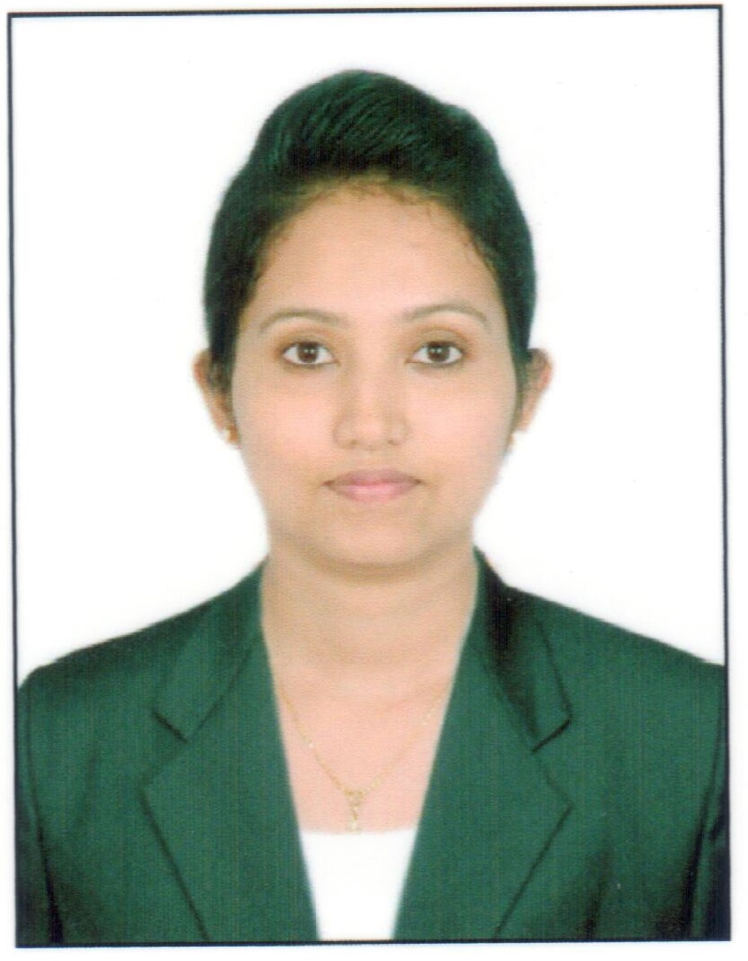
NAMRATHA

E-mail : namratha.369082@2freemail.com

Profile Summary

Compassionate, Dedicated and Trustworthy healthcare personnel with aptitude to stay peaceful in urgent situations. Intervene during emergency, collaborates on multidisciplinary teams. Demonstrated ability to build up constructive relationships with patients, family members, physicians and other health professionals.

Career Objective

Dedicated registered nurse with clinical experience seeking for a challenging & responsible position as a nurse that best utilizes skills obtained from clinical experience and academic
study to support and execute the standards of nursing practice as recognized by the line of work.

Strengths: Personal Attributes

I would describe myself as a proactive, focused, committed, self-motivated, ready to learn person who is willing to give 100% positive attitude towards the responsibilities assigned.

Key Skills:

Analytical Skills, Computer Skills, Interpersonal Skills, Diversity Relations, Team Work, Customer Service Orientation, Communication Skill, Positive Demeanor, Presentation skill, Multi-Tasking, Time Management , Administration Maintaining Confidentiality.

Professional Experience

Manipal Hospital, Old Airport Road, Domlur, Bangalore
April 2013 to April 2015

- Deliver comprehensive care to postnatal mothers with health education.
- Proficient in caring of newborns including, term and preterm babies.
- Assisting in breastfeeding and training the mothers regarding feeding practices
- Care of gynecology patients with pre and post-operative care.
- Comprehensive care to pediatrics of different age groups.
- Implement total patient care through a team nursing process covering 5patients per shift including newborns too.

Vivus Hospital Pvt Ltd,Daswal road,Madikeri

September 2015 Till March 2017

- Managed and co-ordinate the complete care of medical, surgical and Orthopedic patients from admission to discharge with patient driven approach.
- Collaborated with physician to provide care to geriatric patients to improve Quality of care and decrease length of stay.
- Comprehensive care to ENT patients completing pre-operative and Post-operative procedures.
- A dedicated, patient focussed, with proven experience in Obstetrics and Gynecology as well in pediatric and neonatal care having experience of 3years.
- Handled daily caseloads of up to 8-10 patients per shift.

Professional Training Experience

- Medical surgical nursing-
          - Victoria hospital, Bangalore
          - Minto eye hospital, Bangalore
          - ENT Hospital, Bangalore
          - Kidwai institute of oncology, Bangalore
          - NIMHANS, Bangalore
          - Jayadeva institute of Cardiology, Bangalore
          - Institute of nephro-urology, Bangalore

- Mental health nursing-
          - NIMHANS, Bangalore
          - Community mental health centre, Sakalwara

- Pediatric nursing-
          - Vani Villas children’s hospital, Bangalore

- Midwifery and obstetrics nursing-
          - Vani Villas maternity hospital, Bangalore

- Community health nursing-
          - Urban field experience, Gavipuram, Guttahalli,
          - Rural field experience, Bidadi, Ramanagar district

- Nursing administration-
          - Victoria hospital, Bangalore

Educational Qualifications

- Basic B.sc Nursing - Government College of Nursing, Bangalore.
- Pre University (11th and 12th grade) – Mahaveera PU College, Moodabidre.
- 9th and 10th Grade-Jawahar Navodaya Vidyalaya, Mudipu.
- 1ST to 8th Grade– St. Rita’s English Medium Higher Primary School, Jeppu, Mangalore.

Personal Information

Date of Birth : 05-03-1990
Civil Status : Married
Hobbies : Reading and Music
Languages Known : English, Hindi, and Kannada & Malayalam

Additional Skills

- Computer Literacy at basic level.
- Knowledge of Hospital Information System.

Reference

References shall be produced upon request.

