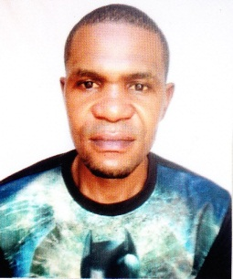
CURRICULUM VITAE
SUNDAY
MOBILE: C/o 0503718643
EMAIL: Sunday.369084@2freemail.com
Dubai – U.A.E

SECURITY GUARD
OBJECTIVE:
A highly resourceful. Flexible, innovative, and enthusiastic security guard. Experienced in promoting a safe environment for staff and customers and able to respond effectively to crime, fire and medical emergencies. Having extensive knowledge of relevant safety equipment, policies, procedures and strategies to deal with emergency situations. Looking for a position as security guard in an exciting and ambitious company that provides room for progression
SUMMARY OF QUALIFICATIONS:
- Reporting any incident directly to Security manager & his assistant
- Initiate effective decision on behalf of superior
- Patrolling all the building
- Controlling and directing access of individual
- Reporting any suspicious item found around the premises
- Monitoring the movement of guest check- in
- Monitoring the movement of guest check- out
- Prevention of crime and loss and waste
- Protection of life and property
- Detection & deterrence of any problem at the location
PROFESSIONAL EXPERIENCE:
- Position: Security Guard
- Company: Aladin Contracting Co Dubai
- Duration: 2 years

DUTIES & RESPONSIBILITIES:
- Patrolled assigned areas on foot or in a vehicle to ensure personal, building, and equipment security.
- Examined doors, windows, and gates to determine that they are secure.
- Informed and warned violators of rule infractions, such as loitering, smoking, or carrying forbidden articles.
- Provided escort services for visitors,
- Provided public assistance, including lockout services and information.
- Prepared routine, standardized reports.
- Performed miscellaneous job-related duties as assigned.
PERSONAL DETAIL:
  - Gender : Male
  - Marital status : Single
  - Date of birth : 31-12-1982
  - Nationality : Nigerian
  - Visa Status : Tourist Visa (Long Term)
  - Language : English

EDUCATIONAL QUALIFICATION:

- High School Certificate

DECLARATION:
I hereby confirm that all statements made and data provided. In this document are true and
Correct to the best of my knowledge and no attempt to conceal or with hold any information.

