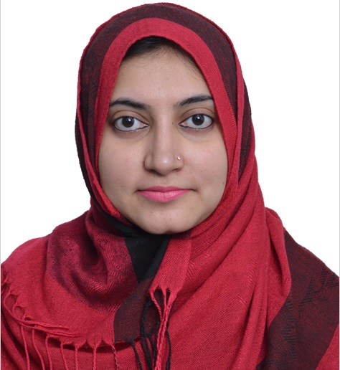
CURRICULUM VITAE
HINA
EMAIL: hina.369097@2freemail.com
Address: Dubai

OBJECTIVES:
Seeking a challenging and growth oriented position in a professionally managed organization, where I can utilize my skills and qualifications for the best benefit of the organization.

PERSONAL BACKGROUND:
Date of Birth : 21 Jan 1985
Nationality. : Pakistani
Gender. : Female
Visa Status. : Till 7th June-2017

EDUCATIONAL BACKGROUND:

- M. Phil Pharmacy (Pharmacognosy), 2016
University of the Punjab, Lahore Pakistan

- Pharm.D, 2013
University of the Punjab, Lahore Pakistan

- B.Sc (Botany, Zoology, Chemistry), 2007
GOVT. APWA College for women, Lahore Pakistan.

COMPUTER PROFICIENCY:
- Application Software – Microsoft Office Standard
- Browser Tools – E-mail and Internet Explorer
- Citing International Journals and using reference software like Endnote
WORKING EXPERIENCE:
As Supervisor Pharmacist

Khawaja Medicine Company, Pakistan (June 2013-Dec 2015)
- Inventory Audit (Medicine warehouse)
- Purchases checks both by Manual and computer records
- Warehouse’s Storage conditions checks

- Updating about Nationals/ provincial Rules/Laws of drugs storage and purchases
- Participation in weekly meetings for warehouse conditions
- Expiry checks
- Updating information about any new product/company‘s products to marketing team.

MAYO HOSPITAL Lahore, Pakistan (March 2013-May2013)
As internee
Training in following 8 departments of hospital
- OPD Pharmacy
- Accident and Emergency
- Urology
- Oncology
- Paeds Medical
- Paeds surgical
- Indoor Medical
- Indoor Surgical.
- Case study on Different Emergency conditions task assigned by head of central Pharmacy of hospital.
CHILDREN’S HOSPITAL, Lahore Pakistan (Sep 2011-Oct 2011)
As internee
Training in following 4 departments of Hospital
- OPD Pharmacy
- Oncology
- General Medical
- Emergency
- Case study on Wilson’s disease patient in hospital.

LANGUAGE KNOWN:

- English
- Urdu

DECLARATION:
I hear by declare the mentioned details are entirely true without any embellishment. I would be highly grateful if I could be appointed to an organization with such high standards & will face against every professional challenge’s that my work will provide me with. References will be provided if required.
__________________
HIna

