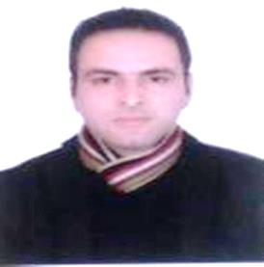
Profile: Adnan
Visa status: Visit
Nationality: Indian
Date of birth: 04-Dec-1988
Email: adnan.369102@2freemail.com

SUMMARY
- Dedicated and focused Administrative Assistant who excels at prioritizing, completing multiple tasks simultaneously, and following through to achieve project goals.
- Answers a high volume of incoming calls while handling in-person inquiries from clients and colleagues.
- Flexible and hardworking with strong drive to succeed.
- Recognized with increasing responsibilities for exceptional work execution.
- Motivated by internal standards of excellence to exceed management expectations

PROFESSIONAL SKILLS
- Software’s: MS-Word, Ms-Exel, Power point, MS-Access.
- Language Skills: English and Urdu (Excellent verbal and written communication)

EDUCATION & TRAINING
- Bachelor in Arts(specialization in Mathematics ) The University of Kashmir, India
- Master of Arts(Public Administration) The Indira Gandhi National Open University, New Delhi
- One Year Diploma in Advanced Networking and Technologies.
- Orientation cum Training programs of Laboratory Management at Institute of Education, Kashmir
- 1 Month training course in administration at District Institute of Education and trainings, Kashmir

Other Particulars

- Interests: Community service, reading, sports, administration, fitness.

Career Experience:

- 2007-2011: Laboratory Assistant at Higher Secondary School, Kashmir.
- 2011-2016: Worked as In-charge co-coordinator at Zonal Education Office Kashmir

AREAS OF EXPERTISE

- Managing the work environment to maximize attention and engagement with the learning experiences.
- Applying highly developed skills of logic and design according to the work.
- Using strategies that promote successful transitions for individuals with exceptional learning & Training needs.
- Handle all media and public relations inquiries.
- Organizing and storing paperwork, documents and computer-based information
- Ordering and maintaining stationery and equipment
- Expertise in Team work & coordination.
- Recruiting, training and supervising junior staff and delegating work as required.

