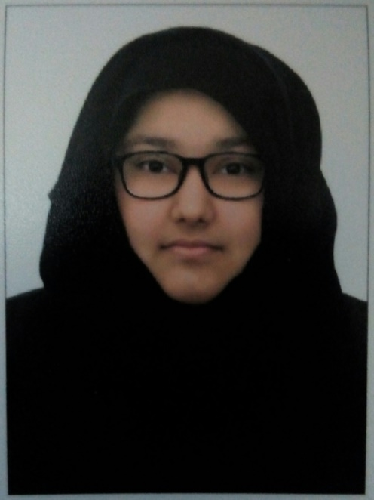
Fatima
Email ID: Fatima.369110@2freemail.com

Career Objective
Looking for an organization where I can enhance my knowledge and from my academic learning give my best to the organizations and provide my best to fulfill the needs of the organization.
Professional Qualities
- Team player with excellent communication skills.
- Creative thinker and analytical problem-solver.
- Superior coordination with colleagues and subordinates because I am young and energetic.
- Good understanding of the importance of internal relationship management within the team.
- Ability of multitasking in a fast-paced environment, while maintaining an emphasis on quality.

- Basic knowledge of Microsoft (word, Excel and presentation)

Job experience
Private English, Math and Science tutor with 1+ year of experience.
Have 1+ year experience in sales.
Temporary admin assistant (1 week) at Omar bin Al khattab school
1 month temporary call centre agent at McDonald's
1 month outdoor sales promoter at du telecom.
Education qualification
Higher secondary school certificate
Al Omadaa ( deans ) international school (2015-2016)

Diploma in business administration( May 5th)
AGI international College Of Law business administration and technology (2016-2017)
Hobbies
- Listening music
- Playing games
- Reading novels and books on psychologgy

personal details

Date of birth: 2 October 1999
Nationality: Pakistani
Religion: Islam
Marital status: single
Visa status: resident visa
Languages known:
• Arabic: Conversational
• English: Fluent
• Urdu: Fluent

