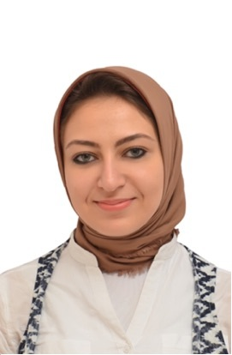
Haneen

Personal data:
- Date of birth : 30th December 1991.
- Place of Birth : Kingdom of Saudi Arabia (KSA).
- Nationality : Egyptian.
- Marital Status : Married.
- E-mail : haneen.369112@2freemail.com

Education:
- Health Authority Of Abu Dhabi (HAAD) License in May 2017.
- Graduated from faculty of Pharmacy Alexandria University (2009 - 2013).
- Overall rank: Very good with honor degree.
- High School: Nabwia Mousa Secondry School.

Work Experience:
- Secondary Pharmacist at Dar Ismail Maternity Hospital (Governmental Hospital) (Dec.2014-Dec.2016) Alexandria, Egypt.
- Secondary Pharmacist at Dr.Lotfy Lolah Pharmacy (A branch of Cambridge and Oxford pharmacies) (Sept.2013 –Nov.2014) Alexandria, Egypt.

Summer training:
- Training at Port Saied Pharmacy (September 2010).
- Training at Al Amriya for Pharmaceutical Industries (September 2011).
- Training at Dr.Hany El-Samadony Pharmacy (August 2012).
- Training at Dr.Marwa El-Mahdy Pharmacy (september2013).

Courses:
- Attended “Clinical Pharmacy Pharmacotherapy And Professional Skills For Clinical Pharmacist” Course (Jan 2014 –Dec.2014 )
- “Training In A Pharmacy” Course (June 2013)
- Attended Bio-Vision conference ( April 2012 )
- Diploma in Neuro-Lingustic Programming (NLP) with Dr.Ibrahim El Fiky (Sept 2011).
- Community pharmacy & pharmacy practice at Future Pharmacy Company (July 2011).
- Communication and presentation skills course at New Horizon (Dec.2010).
- Basic Selling Skills Course at Parkville Company (Nov.2010).
- First Aid Course (2009).
- Pharmacy Practical Application Course at El-Ezaby Chain Pharmacies (2009).
- American language course at Ministry Of Defense Language Institute (2005).

Language:
- Arabic: Mother Tongue.
- English: Fluent Written, Spoken, Reading.

Activities:
- Participated in the charity association “Resala”.
- Was a member in Safwa Pharmacy Club family & Shabab SA7 Family.

Skills:
- Computer skills: 1- Excellent in Microsoft Office Program.
2- Achieved International Computer Driving License (ICDL) Course.
- Personal: Motivated, active and co-operative team player, able to handle pressure.

References furnished upon request.

