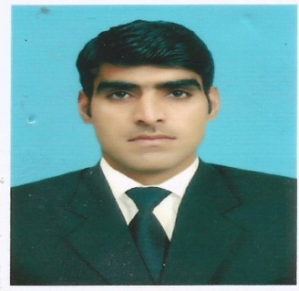
ss
Engr Sajid
Email: sajid.369113@2freemail.com
Immediate Availability

CAREER OBJECTIVE:
To build a shining career in a firm that has good reputation for which I will be co-operative and will exploit my resources to its extremity. I am looking forward to work in a challenging and friendly environment. To be an accomplished professional by gaining exhaustive knowledge about the line of work. All the while engaging in new challenges and learning experiences.

CAREER PROFILE/SKILLS:
- Responsible for total project such as planning ,Execution ,supervision as per specification and schedules
- Project Coordination with architect, Consultants, sub Contractors etc.
- Checking and coordinating detailed Interior drawings
- Electrical installations
- Coordination with MEP contractor + other subcontractor.
- Coordinating plans with structural, electrical and mechanical engineer.
- Sourcing of products and coordination in material procurement
- Get the quote from subcontractor to finalize the work.
- Project Correspondence + Submission of variations and updating accordingly.
- Monitoring the progress of the project
- Attending technical and progress meeting with Project Manager & Project Team
- Checking the quality of work and assuring the quality of works

PROFESSIONAL WORK EXPERIENCE:
Organization: Al Mutakamila Electrical Contracting LL.C
(Electrical Contracting Company Fujairah UAE)
Tenure: June 2015 – To till Date
Designations: Electrical Engineer
Responsibilities:

- Electrical Installations with updated system
- Electrical panels
- Draw Electrical Drawings on advance Level(AUTO CAD)
- Manage and Supervision of site work
- Cable Sizing with professional techniques
- Preparation of Load Scheduling
- Preparation of Electrical planning and Strategies

Organization: Qazi Associates Electrical Consulting Engineers
(Leading Engineering Consultant Company of Pakistan)
Tenure: May 2012– April 2015
Designations: Electrical Engineer
Responsibilities:

- Assisting the Senior Electrical Engineer on routine works
- Load scheduling and Electric panels
- Cable Sizing
- Electrical Installations
- Electrical Drawings with Auto CAD
- Any duty Assign by Seniors

Organization: National Tele communication Corporation
(National Tele Communication Of Pakistan)
Tenure: December 2013 –May 2013
Designations: Internee

Responsibilities:

- Assisting Electrical Engineers
- Practical Utilization of Bookish Knowledge
- Load scheduling and Electric panels
- Cable Sizing Knowledge
- Getting Knowledge of Electrical Installations
- Electrical Drawings

ACADEMIC EDUCATION:

DEGREE | EXAMINING BODY: | YEAR
Bsc Electrical Engineering | University of Engineering Peshawar, Pakistan | 2013
HSSC | Islamabad Model College Islamabad, Pakistan | 2008

CERTIFICATION/ ADDITIONAL SKILLS:
- MS Office (All versions, MS Word, MS Power Point and MS Excel)
- Electric Workbench (Excellent Utilization in all aspect)
- Matlab (Good practical utilization in all aspect)
- AutoCAD (Best practice in all aspect)

TRAININGS & WORKSHOPS:

AUTOCAD GURU Training with SBS Year - 2014
- Intermediate and advance levels of AUTOCAD

PERSONAL INFORMATION:

Date of Birth : 20 February, 1990
Driving License : UAE
Religion : Islam

