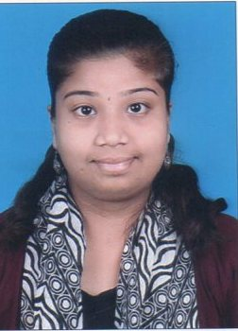

PREEJA
Email Id: preeja.369117@2freemail.com
Career Objective
Seeking a position of Receptionist where expertise in greeting customers, answering phone and handling mail will be fully utilized to increase the company’s client base and operational efficiency
Profile
- Having 2 year experience as a Receptionist with Kalikamata
Enterprise in the year 2015 till January 2017.
Duties
- answer telephone, screen and direct calls
- take and relay messages
- provide information to callers
- greet persons entering organization
- direct persons to correct destination
- deal with queries from the public and customers
- ensure knowledge of staff movements in and out of organization
- monitor visitor access and maintain security awareness
- provide general administrative and clerical support
- prepare correspondence and documents
- receive and sort mail and deliveries
- schedule appointments
- maintain appointment diary either manually or electronically
- organize conference and meeting room bookings
- co-ordinate meetings and organize catering
- monitor and maintain office equipment
- control inventory relevant to reception area
- tidy and maintain the reception area
.

Academic Qualification
- BSS Diploma in Early Childhood Care and Education (ECC.Ed) from BSS Vighnaharta Teaching Institute in the academic year 13-14.
- Bachelor of Commerce from Mumbai University in the year 2015-2016

Computer Skills
- Basic computer knowledge.(Ms Word, Ms Excel, Ms Power Point)
- Tally ERP 9.0

Personal Details`
Name : Preeja
Date of Birth : 06th July, 1991.
Nationality : Indian (hindu)
Languages Known : English, Malayalam, Tamil & Hindi.
Hobbies : Reading and Listening musics
Visa Status: Visit Visa

Declaration:
I would welcome the opportunity given by your organization with a promise to given my best as the need of jobs.

