PERSONAL RESUME

1 | Name | Sahaya. | 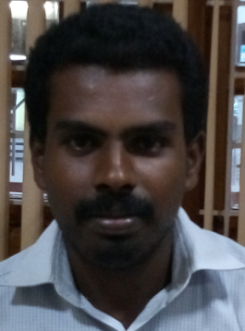
2 | Date of birth | 08.06.1993. (23 years)
3 | email ID | Sahaya.369118@2freemail.com
4 | Educational Qualification | B.E. (Civil Engineering),  Anna University, Chennai.
5 | Experience | 3 years.
6 | Current working | Civil Supervisor in  S.S. Associates,  No.5-B, Pammal-Thiruneermalai Road, Pammal, Chennai-600 075.
7 | Languages known | Tamil, English and Hindi.
8 | SKILLS  - Time conscious.  - Knack in getting things done.  - Expertise in constructing according to plan.  - Aptitude to understand the mentality of workers.  - Ability to manage Masons, Electrician, Plumber, Painter, Tiles /Granite/ Marble Layer, Driver, JCP Operator,etc.  - Genius in assessment of work load and engagement of proper workers.  - Brilliant in mathematics of quantity of materials.
9 | Computer knowledge | AUTOCAD, 2D, 3D & Chief Architect.

(Sahaya)

