Curriculum Vitae
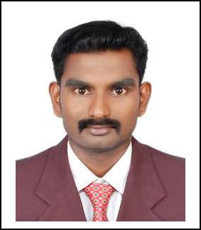

Ebenezer

E-mail : Ebenezer.369122@2freemail.com

Objective

To work in an organization which provides opportunities for growth, learning and scope for the implementation of my skills and thereby give my best for the organization.

Education Qualifications

2014 | Graduated in Civil Engineering from University College of engineering,
 | Nagercoil with 8.19 CGPA
2011 | Diploma in Architectural Assistantship from Moderator Gnanadasan Poly. Clg.,
 | Nagercoil with 90.58%
2009 | HSC passed from Scott Christian Hr. Sec. School, Nagercoil with 69.75%
2007 | SSLC passed from Scott Christian Hr. Sec. School, Nagercoil with 72.6%

Work Experience

1. COMPANY NAME

: Rees Builders, Nagercoil

DURATION

: December 2015 to December 2016

DESIGNATION

: SITE ENGINEER

PROJECT

: Residential buildings

Responsibilities

- Supervising project employees including external contractor and sub-contractors

- Setting out project works in accordance with drawings and specification

- Preparing inquiry and order documents for sub-contractors

- Ensuring the availability of the types and quantities of the materials required in site to confirm to the specification

2. COMPANY NAME

: Anjali Construction Company, Kottarakara

DURATION

: January 2015 to November 2015

DESIGNATION

: SITE ENGINEER

PROJECT

: Roads and Bridges

Responsibilities

- Inspecting quality of work as per DPR specifications for roadworks

- Supervising construction of roadwork activities like cutting, filling, formation of base and surface layers

- Setting out curves and estimating degrees of super elevation of roads

- Preparation of M-book

- Maintaining of daily record

3. COMPANY NAME

: KG Bright Enterprises India Pvt.Ltd., Chennai

DURATION

: February 2014 to August 2014

DESIGNATION

: SITE ENGINEER

PROJECT

: YAMAHA MOTORS INDIA PVT LTD

Responsibilities

- Designing interiors for showrooms

- Preparing plans and working drawings

- Engaging in client meetings and ensuring their satisfaction

- Producing and processing final measurements

Technical Skills

- Auto Cad

- 3D Studio Max

- Stadd Pro

Personal Details

Name | : | EBENEZER
Date of Birth | : | 20.03.1991
Gender | : | Male
Nationality | : | Indian
Languages Known | : | Tamil, English
Hobbies | : | Learning New Software

Passport Details
Place of issue | : | Madurai
Date of Expiry | : | 24/04/2024

Declaration

I hereby declare that all the details furnished above are true to the best of my knowledge.

DATE :

PLACE :

Yours faithfully,

Ebenezer

