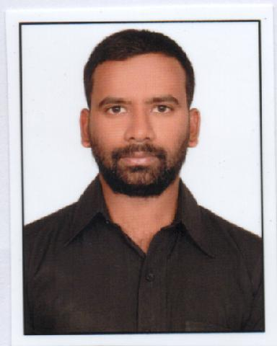
MOHAMMED
MOHAMMED.369126@2freemail.com

M.sc(Microbiology), B.ed

CAREER OBJECTIVE

Reliable High School Biology Teacher who understands the very best ways to get students interested in biology. Adept at presenting dissection projects to all students, creating engaging lesson plans and working with faculty to offer educational opportunities to students.

Seeking a position of a Biology Teacher at your school to utilize my capabilities and professional experience for the academic progress of the students

EDUCATIONAL QUALIFICATIONS

Post Graduation: Master of Science (M.Sc)

Department of Micro Biology

Osmania University, Hyderabad, India.

Graduation 1: Bachelor of science (B.Sc)

Department of Biotechnology

Kakatiya University, Hyderabad, India.

Graduation 2: Bachelor of Education (B. Ed)

Kakatiya University, Hyderabad, India.

- WORK EXPERIENCE

Worked as High School Teacher in Suffah high school from June 2010 to April 2011.

2. WORK EXPERIENCE

Worked as High School Biology Teacher in Seventh Day high school from June 2011 to April 2013.

3. WORK EXPERIENCE

Worked as Lecturer in Department of Biotechnology in Bharati Degree College from June 2013 to March 2017.

Responsibilities

Ability to conduct classes of students from fifth grade to twelfth grade in Biology. Recorded all grades and progress updates for administration and parents.
Encouraged students to participate in classroom discussions to maximize learning. Utilized multi-media approaches to classroom instruction to reach all students.
Mentored students one-on-one to improve test scores.

Improved lesson plans to take advantage of new materials.

Developed several ways to help students get more involved in each biology lab experiment. Adapted and updated curriculum to keep content relevant for students.
Prepared the ready reference notes for the purpose of students' exams and future usage.

Recorded progress of each student by conducting periodic assessment tests increasing stable behaviors in the classroom.

Consistently recognized on both oral and written evaluations as exceed expectations.

Fostered a classroom environment conducive to learning and promoting excellent student/teacher interaction.

HIGHLIGHTS

Exceptional ability to work with students Excellent computer and Internet abilities
Able to work well with all faculty members and administration Dedicated to the proper education of all students
Reliable teacher who remains available to students after the school day is over

COMPUTER PROFFECIENCY

Office package Operating systems

: MS-office Excel.

: Windows XP/Vista/7.

PERSONAL PROFILE

Date of Birth | : | 4th October 1991
Religion | : | Islam
Marital Status | : | married
Nationality | : | Indian
Language Known | : | English, Hindi, Urdu,Telugu
Visa Status | : | Visit visa

