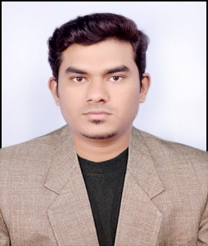

Mohammed
Mohammed.369133@2freemail.com

CAREER OBJECTIVE:
“To use my skills for the welfare & upliftment of the Organization and to serve to the fullest of my ability to fullest of my ability to fulfill my ambitions within the scope of an organization”.

CAREER PROFILE:
- Worked under Government Project as IT Support Executive in IT SUPPORT DESK (Rooman Technologies)
- Solving the hardware issues of systems, installing OS & Required software
- Worked under SBM, SBI, SBT Banks for system deployment all over Karnataka.
- Worked under ticketing tool.
- Installation of printer and additional devices like biometric devices, web cam.
- Worked on ammy admin & Team viewer for transferring & Installation of software’s, drivers.
TECHNICAL SKILLS:
- Operating Systems : Windows, ubuntu, configurations, installations.
- Protocols : DNS, HTTP, IMAP/POP3, SMTP, DHCP, NAT
- Hardware installation : having a good knowledge in hardware installation
- Trouble shooting : I can resolve the hardware and networking problems
- Routing , switching : knowledge of cisco routers and switches, Handling Cisco routers and switches.
- Installation of cctv :can install the security cameras. Install, maintain, or repair security systems i.e camera DVR
- Installation of printers : I can install the printers of different types
- Active directories : I can do the different active directories and commands
- Understanding of TCP/IP :Strong understanding of Active Directory, LAN, DHCP, TCP/IP and DNS
- MS- office :ms-word, power point,ms-excel and many more

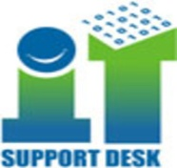
PROFESSIONAL WORK EXPERIENCE:

Organization: IT Support desk pvt.ltd
(customer IT Support) Bangalore, india
Tenure: June 2015 – June 2016
Designation: System engineer

RESPONSIBILITIES:

- Solving the issues taking remote assistance.
- Solving the problems of Ethernet cables. Wi-Fi issues.
- Solving the hardware issues of systems, installing OS & Required software
- Monitoring & maintaining system Performance.
- Application level and software level supporting & Installing User needful
software's/Applications.
- Interaction with the users over Email, telephone & Provide resolution for the user's issue.
- Solved with the help of Team viewer & Ammyy admin.
- Installation and management of various windows desktop and laptop systems.
- All types of printer/Scanner Installation, Configuration & Trouble shooting.
- Installation of Antivirus, Troubleshoot AV Update for client Support.

ACHIVEMENTS:

- Made me the team leader during the 6th months of service.
- I did different type of works in the same time and same company.

ACADEMIC EDUCATION:

Qualification type | discipline | EXAMINING BODY: | YEAR
Diploma | Electronics & communication | Department of technical education, Bangalore(India) | 2014
SSLC | ------------------ | KSEE Board | 2010

CERTIFICATION/ ADDITIONAL SKILLS:
- System Administrator : (Hardware & networking, CCNA, Windows server 2008 R2, Exchange server 2010)

TRAININGS & WORKSHOPS:

- Field Technician and network storage
- CCTV installation
- Knowledge of IP addressing, DHCP, DNS
- Routing, switching.
- SQL, VMware

PERSONAL INFORMATION:

Date of Birth : 24/01/1994
Sex : Male
Marital status : Single
Religion : Islam
Nationality : Indian
Languages known : English, Hindi, kannada, Urdu.

DECLARATION:
I hereby declare that the above statements are true and complete to the best of my knowledge.

