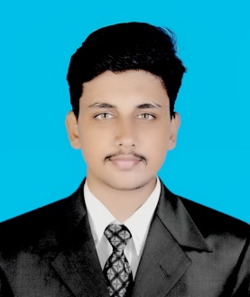
SUHAIL P.C
BE (Computer Science Engineering)
Phone: +91 9746830969(IND) , +971 505835308 (UAE)
Email: suhailrp89@gmail.com

CAREER OBJECTIVE

To get the hold of challenging career with a solid company utilizing the chance to offer proven and developing skills inside the company.

SUMMARY:

- Qualified graduate in Computer Science and Engineering.
- Completed training in SAP Sales and Distribution.
- Completed project in SAP Sales and Distribution module.
- Completed openSAP course: Design the Future of Your CRM.
- Completed openSAP course: SAP Digital Boardroom in a Nutshell.
- Completed project using Android Studio, MySQL and SAP.
- Programming Languages JAVA, SQL, PHP, C and C++.
- Operating Systems: Windows 98, 2000, XP, 7, 8, 10 and Linux.
ACADEMIC QUALIFICATIONS

2016 B Tech
Computer Science and Engineering.
Srinivas Institute of Technology, Mangalore.
Visvesvaraya Technological University (VTU), Belgaum.

2011 12th Grade
Don Bosco H.S.S, Thrissur, Kerala.
Kerala State Board.

2009 10th Grade
Rani Jai H.S.S, Kannur, Kerala.
Kerala State Board.

PROJECT DETAILS

Veedu – The complete housing solution

Designed and devoleped an android application for purchasing building materials.
PERSONAL PROFILE

Father’s Name : Abdul Nazir P.K
Nationality : Indian
Gender : Male
DOB : 14/09/1992
Age : 24
Passport No : P4628929
Date of expiry : 08/11/2026
Address : Kannur,
Kerala, India

LANGUAGES KNOWN:

- English, Malayalam, Hindi and Arabic (write and read).

PERSONAL SKILLS

- Willingness to learn new things
- Intellectual &Hard working
- Good communication skill
- Ability to convince people
- Good management skill.

REFERENCE

Dr. Shrinivasa Mayya D
Principal,
Srinivas Institute of Technology,
Mangalore, India.
srimayya@gmail.com
Cell: +919448328115

Prof. Mohan K Gowda
Associate Professor
Srinivas Institute of Technology,
Mangalore, India.
Email: hamohax@gmail.com
Cell: +919743704860

DECLARATION

I hereby declare that the above information is correct to the best of my knowledge and belief.

________________________
Suhail P.C

