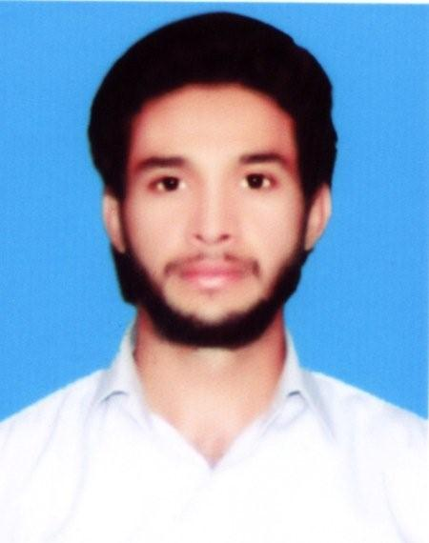 | SYED  Chemical Engineer  Born: 1992  Email: syed.369154@2freemail.com
Personal Profile | - Maintain leadership roles in professional careers in field of choice with high level of competence, ethics and safety consciousness.  - High Personal Standards, Self Reliant and Good Interpersonal Skills.  - Innovative and Strong Planner.  - Set aims and targets and use a methodical approach to achieve them while leading from the front.
Professional Experience | ITTEHAD CHEMICALS Above 4 years of experience  SHIFT IN CHARGE  Responsibilities:  - As a chemical engineer, managing employees at work, maintaining process parameters, emergency handling.  - Running the plant with optimum efficiency and productivity.  - Worked with Alfa laval team for erection of Evaporation unit.  - Worked with Bluestar company for erection of Ion exchange membrane plant 6th generation latest technology.  - Well aware of design specifications ,material specification, international standards,codes,symbols.  - Erectioning of sulphate removal plant.  - Working as a SHIFT IN CHARGE as a whole(Brine purification plant, Ion Exchange membrane(0 gap technology),Evaporation , HCl plant, Cl2 liquefaction plant and Caustic solidification plant) .  - Managing all the staff in shifts, especially in silent hours.  - Coordinating with various departments like instrumentation, electrical, mechanical on routine basis.  - Planned and unplanned shutdown together with the maintenance department team.  - Supervises production processes to ensure implementation of company standards.  - Establishes Quality control standards (ISO 9001) and procedures & also Environment standard (ISO 14001) as we are dealing with Chlorine an Hydrogen poisonous and explosive gases. Ensure strict adherence to those standards.  - Perform process & personal safety procedure audits, identify discrepancies and drive connections as needed.  - Make sure to the external and internal audit teams that we are following the ISO standards for process and product audit.  - Establishes production standards of efficiency, minimum wastages and maximum utilization of resources (equipments, raw materials, manpower).  - Prioritize the maintenance and operation activities of “CAUSTIC 50%” production at Evaporation plant, HCl synthesis ,caustic solidification plant.  - Issue cold and hot work permits with collaboration of safety department.  - Daily plant activity and production reports.  - Made P&IDs of Different Plants by using Microsoft Visio.  - Worked at CONTROL ROOM(DCS BASED) .  - Now controlling all as a shift in charge.  INTERNSHIP 04 Jun- 31 July 2011  Ittehad Chemicals pvt Ltd.  - Worked at Production plant of NaOH in Liquid and Solid form.  - Worked at the Plant of HCl & H2SO4.  - Made comprehensive report on process involved in manufacturing of NaOH.
Education & Qualification | UET LAHORE  B.Sc.( Chemical Engineering) 3.27 CGPA  Govt. Degree College Shahdra Lahore.  F.sc. (Pre-Engineering) 2006-08  A Grade  Govt. Central Model High School Lahore.  Matriculation.(Science) 2004-06  A Grade
Final Project | Project on production of 10 tons/day of BUTYL RUBBER.  - Material and Energy balance.  - Designing of the equipments.  - Simulation of the Design on ASPEN PLUS.
Extra curricular  Activities | - CAPTAIN of University CRICKET team.  - CAPTAIN of ITTEHAD CHEMICALS cricket team.  - Recently won the Pakistan Engineering Council cricket gala 2016 tournament as a captain an awarded as a best player of the tournament.  - Always lead the team and want to lead.  - Good player of BADMINTON and FOOTBALL.  - Member of Debating Society.  - Participated in 7th All Pak Declamation Contest as a senior member.
Certifications | - ASPEN PLUS Simulation and designing software.  (UET Lahore)
 | - Microsoft Office, Microsoft Visio

