CURRICULUM VITAE

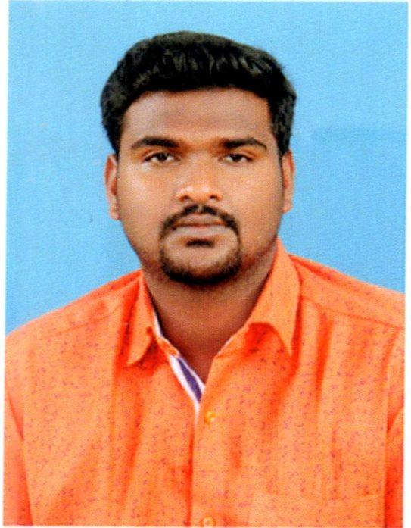
Gowri
Email: gowri.369198@2freemail.com

Academic Details

percentage | Institution | University / Board | Year of passing | course
52% | SRM University | university | 2016 | BTECH
63% | Scism Matriculation Higher secondary School | State board | 2010 | 12
66% | Theni Kamavar Sangam Matriculation Higher secondary School | Matriculation | 2008 | 10

Desktop skills

- PC Hardware, Installation, Assembling and Trouble shooting.
- Installing and Configuring Operating System like XP, 2003 Server, Windows7 and 2008Server.
- Installing Anti-Virus, different Applications and Patch Management.
- Network Configuration and Trouble shooting.
- Configuring Network Printer and Device Drivers.
- Configuring and trouble shooting of messaging client Microsoft Outlook, Outlook Express.
- Different back-up like HDD, User data, outlook, outlook express and Restore.
Server Skills

- Installing and Configuring ADS in 2003 Server,
- Configuring Exchange server Outlook and Outlook Express Clients.
- Configuring DNS, DHCP, Group Policies, Security Policies, Profiles and Terminal Service.
- Creating and Managing Users/ Group Accounts, Configuring File Permission, Profiles, Shared Folders &Security.
- Configuring Mail Clients like MS Outlook, Outlook Express and Backup of mails
Certification
Done post graduate program in software engineering – java specialization at NIIT limited
Logic Building and Effective Problem Solving
- Identify the input and output requirements of a computer problem
- Explain programs and programming language
- use variables and constants
- Identify the various tools for problem solving
RDBMS and T-SQL Programming
- Identify the sql server tools
- Retrieve,summarize and group data
- Use functions to customize result set
- Manage databases,tables and result sets
Programming in Java
- Identify the features of object orientation
- Create object-oriented java applications
- Use decision-making constructs and loop constructs
- Process string using regular expressions
HTML5
- Create an html webpage
- Work with tables and frames
- Create dynamic webpages
- Implement geolocation and offline support for data
Professional skills
- Improve communication skills
- Work effectively in a team environment
- Demonstrate critical thinking
- Improve self-presentation skills
- Understand methods of planning and prioritizing
Developing web applications using servlets and jsp
- Understand HTTP request/response cycle and servlet lifecycle
- Identify the services provided by the web container
- Implement the mvc design pattern
- Develop JSP pages using EL and JSTL
Developing Cloud Apps Using Google Cloud App Engine
- Identify the fundamentals of cloud computing and google cloud platform
- Build an app engine application using google plugin and maven
- Handle user authentication and forms
- Use app engine datastore to store data

Personal Details

Date of Birth : 23-05-1993
Sex : Male
Languages Known : English Tamil

Personal Attributes

- Like to work with team.
- Seeking complete satisfaction with work.
- Maintaining good relationship in the organisation
Declaration

I hereby declare that the above mentioned particulars are true to the best of my knowledge.

Place : Dubai Yours truly,
Date : (Gowri)

