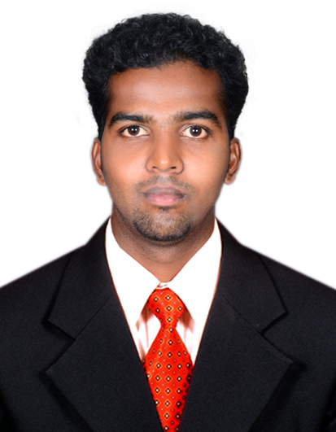
Godju
E-mail: godju.369201@2freemail.com

VISA DETAILS: VISIT VISA

CAREER OBJECTIVE

Seeking a challenging position in your esteemed organization where my technical liaison and co-ordination skills can be effectively utilized to improve operations and contribute to the company’s growth

BASIC ACADEMIC CREDENTIALS

Qualification | Board | Institution | Year of passing | Percentage
Bachelor of Mechanical Engineering | ANNA university, Chennai. | KCG college of technology | 2014 | 66%
HSC | State Board | Scott Christian higher secondary school | 2010 | 85%
SSLC | State Board of Tamilnadu | SMRV higher secondary school | 2007 | 70%

EMPLOYMENT DETAILS:

Company: AAGNA GLOBAL SOLUTIONS PVT LTD
Experience: From JUN 2015 – MAR 2017.

CONSULTANT

- outbound telemarketing
- market research and survey
- lead generation services
- follow-up and voice broadcast
Company: RS YARNS & POWER PVT LTD
Experience: From JUN 2014 – MAY 2015

OPERATIONS AND maintenance ENGINEER

- Identifies and captures opportunities for improvement in equipment maintainability and reliability.
- Keeps current with latest equipment, technologies, and Quality methods.
- Promotes importance of data and service quality within maintenance community.
- Ensures application of asset management and quality systems data and accurate, timely data entry and reporting.
- Participates in technical audits and compliance assessments, and follows up on closure of remedial action plans.

CORE KNOWLEDGE AND FUNCTIONAL SKILL AREAS

- Basic in computers
- Operating systems
- Microsoft Office tool
- Auto cadd
- Ansys software
- Packages: MS Word, MS Power Point, MS Excel

AREA OF INTEREST

- Manufacturing
- Production
- Quality Testing

ADDITIONAL QUALIFICATION

Completed Quality Testing (ASNT LEVEL II) studied at NATIONAL INSTITUTE FOR TECHNICAL TRAINING.
- Ultrasonic Testing
- Magnetic Particle Testing
- Liquid Penetrant Testing
- Radiographic Testing
- Visual Inspection

STRENGTH
- Good team player with a positive attitude towards reaching the set goals.
- Ability to work under dynamic, multi faceted pressure for completing the targets.
- Integrity and commitment towards work.
- Strong Aptitude to learn for every aspect of new transactions and developments.

INTERPERSONAL SKILL

- Good verbal and written communication skills
- Ability to work hard
- Ability to build motivation
- Creative & self-confident
- Positive approach thinking

Personal Attributes

- Accuracy, Excellent organizational skills, Confidentiality, Planning and Time management
- Initiative, Reliability, Stress tolerance
- Willingness to work in a flexible schedule and high workload
- Punctual and aggressive towards all sort of work.

WORKSHOPS
- Attended a workshop conducted by experts hub at SRM engineering college on “Automotive skills”

ACADEMIC PROJECT
- Optimization of shape of bumper beam section considering the front rigid wall impact analysis.
- Motor actuated two wheeler side stand setup.

LANGUAGES KNOWN

Speaking: Tamil, English, and Malayalam
Reading: Tamil, English
Writing: Tamil, English

PERSONAL DETAILS

- Date of Birth: - 05 NOV 1990
- Language Known: - English, Tamil, Malayalam and Hindi
- Marital Status: - Unmarried
- Nationality/Religion: - Indian / Christian
- Interest & Hobbies: - Music and sports

DECLARATION

The above-mentioned information is true and correct to the best of my knowledge and belief. If I am selected and given a chance to serve in your esteemed organization I shall prove my best and ability to the entire satisfaction of my superiors.

Place: Dubai GODJU
Date: (Signature)

