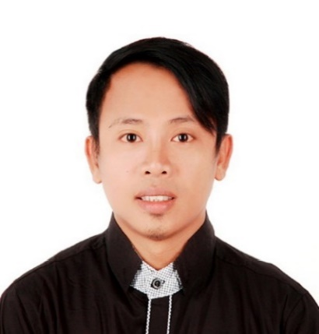

SANJIV

SANJIV.369210@2freemail.com

CAREER OBJECTIVE:
To be a part of a very effective environment wherein my knowledge and experience can be shared and develop and Looking for opportunities where I can improve my qualified skills. Undertake challenging assignments and crave for learning new things. Seek a Responsible Career Opportunity in which I can successfully utilize my Skills towards the set objective of the organization.
TECHNICAL SKILLS
Operating Systems: Microsoft Office (Word, Excel, Outlook, PowerPoint)
ACADEMIC QUALIFICATION:
- Bachelor of Science in “Psychology” – (2002 – 2007)
Holy Cross of Davao College, Sta. Ana Avenue Davao City, Philippines
Working Experience:
Company : Masao Beach Resort
Position : Customer Service
Duration : September 2013-March 2017

Roles and Responsibilities:
- Facilitates reception area to be more entertaining and approachable.
- Determine the problems of the customers which needs attentions for a fast resolution
- Ensure that customers satisfaction with regards to the quality of service we are serving.
- Answer phone and emails with concerns to question of existing transaction.
- Schedule accommodation for clients that needs reservation.
- Collect cash in exchange of services rendered and tender change to customers.
- Ask customers for feedback on the service
- Ensure cleanliness, neatness and sanitization of the resorts.
- Conducting meeting and other value ideas to share to coworkers for effective results
- Receiving payment from the customers after leaving the resorts
- Preparing materials that needs before being occupied to the area.
- Innovating new advertising method to promotes high information to our Resort
- To make a summary report in monthly basis for previous transaction
- Give a high quality of first class service of the resort.

Company : Travel Inn Hotel
Position : Front Desk Receptionist
Duration : Feb. 2012-Sept. 2013
Duties and Responsibilities:
- Assisted the promotion teams with the planning of advertising packages and promotions.
- Oversaw all details that must be reviewed before accepting booking.
- Take control in receiving phone calls and answering inquiries in emails
- Responsible for the day to day dealing of customers, guiding and solving the queries of customers.
- Promotes a good relationship to my co workers
- Send a weekly report to assess the number of clients visiting the hotel.
- Enhances a calibrated flow of services catered to the clients.
- Follow up concerns and recommendation of staff in line with work efficiency.

Company : Quality Inn Hotel

Position : RECEPTIONIST/Hotel Front Desk
Duration : Jan. 2009-Dec 2011
Roles and Responsibilities:
- Politely greet the customers by approaching them with a positive feeling.
- Guiding them to their line of preference of room accommodation
- Monitoring of inbound and outbound logs of guest.
- Check profile of each guest listed from accommodation
- Offering packages promo through telephone and emails add.
- Asking them nicely about their personal concern.
- Answer them politely about their inquiries.
- Take control of phone calls as outside customers concern
- Must take feedback satisfaction of the customers
- Give a sense of high quality services in making them satisfy
- Always provide their need as a priority.

Company : Davao Honda Center Inc.
Position : Admin/Human Resource Assistant
Duration : March 2008 - October 2008
Roles and Responsibilities:
- Deliver excellent employees management in working place.
- Helps on conducting assessment on employees with regards to performance appraisal on employees with regards to the profile of employees.
- Maintain safety and regulation to effective implementation.
- Imposing rules and regulation with regards to company policies.
- Creates a healthy and friendly environment in the workplace.
- Implementing sanctions to employees that needs to be reprimanded.
- Conducting awareness to newly hired employees.
- Encourage other workers to do a high-quality performance in their respective departments.
Company : Davao Oriental Tours Inc.
Position : Travel Assistant Coordinator
Duration : September 2007 - March 2008
Roles and Responsibilities:
- Deliver excellent customer service to the walk- in clients in the receiving area.
- Arrange flights and mainly booking to the client’s destinations
- Making a comfortable way on making hotel booking depending on client’s preference.
- Promotes a hassle free for tourist to make a wise decision on choosing places
- Making accommodations and Secure necessary documentation such as passports, visas, or other clearances.
- Settle requisite documentation for proper booking and flights.
- Giving a proper option for client’s satisfaction with regards to their choices.
- Always leave a good impression for full satisfaction.

