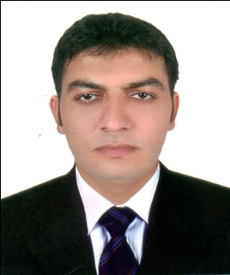
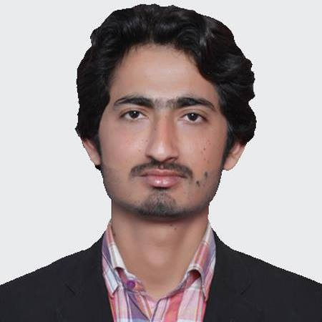
ABID
Email: abid.369246@2freemail.com
Visa Status: Visit Visa

CAREER OBJECTIVE:

To join a value driven organization for mutual benefits, giving me a chance to apply Technical skills gained through work experiences and personal development leading to the achievement of organization goals.
EXPERIENCE SUMMARY:

Five Years of work experience in Beverages & Food Industries, Acquired Analytical, Problem Solving and Leadership abilities in my previous roles
PROFESSIONAL WORK EXPERIENCE:

- Organization: VOLKA Foods International
FMCG
Tenure: 09/05/2014 - 28/10/2016
Designations: Mechanical Technician
JOB DESCRIPTIONS:

  - Pump Repairing
  - Valves Repairing
  - Plunger Repairing
- Plant maintenance
- Conveyor maintenance
- Workshop Official Documentation
- Material Issuance and demand from Market
- Maintain Fabrication Workshop
- Made SS & MS Tanks (Single & Double Jacket)

- Organization: Coca Cola Beverages Pvt. Ltd
FMCG
Tenure: 20 April 2011 to 20 April 2014
Designations: Plant Operator
Job Description:

Plant maintenance
- Pump Repairing
- Trouble Shouting
- Plunger Repairing
- Valves Repairing
- Filler: Operation & Maintenance
- Washer: Operation maintenance.
- Caser & Decasser Operation & maintenance.
- Conveyer Maintenance
- Workshop Work
ACADEMIC EDUCATION:

DEGREE EXAMINING BODY: YEAR
- B.Tech (Mechanical) Bahauddin Zakariya University, Multan Pakistan 2013
- D.A.E Mechanical Punjab Board Of Technical Education Lahore, Pakistan 2010

COMMUNICATION AND INTERPERSONAL SKILLS:

- Strong organizational, managerial, problem solving, interpersonal and negotiation skills.
- Confidently able to work independently or in a team to deal effectively with educators & employees.
- Flair to organize & prioritize tasks to meet deadlines.
- Ability to manage multiple projects with minimal supervision.
- Have a good level command over English and Urdu Languages.

CERTIFICATION/ ADDITIONAL SKILLS:

- 06 month Computer Application Course
- MS Office All versions, esp. MS Word, MS Power Point and MS Excel
- MS Excel MS Formulae, Reports Automation, Macros, Presentations

INTERESTS AND HOBBIES:

- Hobbies include anything to do in arts, music, poetry, reading historical books, and Enjoy and actively participate in a wide variety of sports, and creative activities.

PERSONAL INFORMATION:

Date of Birth : 05-Feb-1988
Religion : Islam
Nationality : Pakistani

