Ralph  Home Address: Abu Dhabi, UAE  Email Address: ralph.369261@2freemail.com |  | 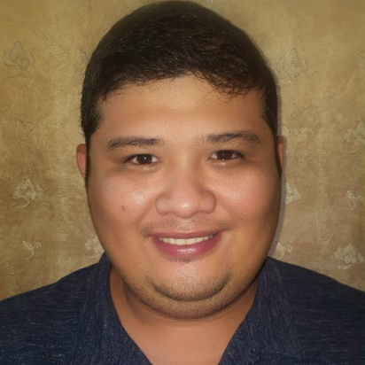  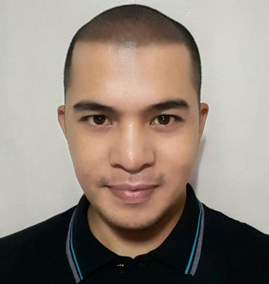
PERSONAL DETAILS  OBJECTIVES  PROFILE SUMMARY | Profession: HAAD Registered Nurse  Date of Birth: September 19, 1985  Age: 31 years old  Place of Birth: Negros Occidental, Philippines  Civil Status: Single  Citizenship: Filipino  Languages Known: English: Fluent; Filipino: Mother Tongue  Visa Status: Residence Visa  - To obtain a position at your company where I can maximize my interpersonal skills, quality assurance, program development, and training experience.  - To find great learning experiences that can be useful with my future career.  - To look for a full time position in an environment that offers greater challenge, increased benefits for my family, and the opportunity to help the company advance efficiently and productively.  A result-oriented professional with more than 5 years of experience as a Registered Nurse:  - Enthusiastic, compassionate nursing professional with 6+ years of experience as a Registered Nurse.  - Possess incomparable knowledge of the nursing processes, professional standards of nursing and a track record of maintaining confidentiality and protecting sensitive data at all times.  - Dynamically capable of initiating discharge planning based on assessed needs specifically keeping in mind the organizational and department safety standards.  - Current HAAD Licensed as a Registered Nurse, BLS and ACLS certified.  - Devoted to provide utmost level of ease and care to patients.
EMPLOYMENT  MACHINES AND EQUIPMENTS HANDLED OR USED:  EDUCATION  TRAININGS & SEMINARS ATTENDED  LICENSURE EXAMINATIONS | Care & Cure Health Services  Abu Dhabi, UAE  June 9, 2015 – Present  Registered Nurse  Binalbagan Infirmary (OPD, Medical-Surgical & Emergency Nursing)  September 10, 2011 – May 30, 2015  Staff Nurse  Additional Duties and Responsibilities:  Assistant Coordinator, Health Emergency Management Staff  Binalbagan Infirmary  Officer in Charge, Volunteer Corps  Binalbagan Infirmary  Secretary to the Chief of Hospital  Binalbagan Infirmary  - Promotes and restores patients' health by completing the nursing process; collaborating with physicians and multidisciplinary team members; providing physical and psychological support to patients, friends, and families; supervising assigned team members.  - Identifies patient care requirements by establishing personal rapport with potential and actual patients and other persons in a position to understand care requirements.  - Establishes a compassionate environment by providing emotional, psychological, and spiritual support to patients, friends, and families.  - Promotes patient's independence by establishing patient care goals; teaching patient, friends, and family to understand condition, medications, and self-care skills; answering questions.  - Assures quality of care by adhering to therapeutic standards; measuring health outcomes against patient care goals and standards; making or recommending necessary adjustments; following hospital and nursing division's philosophies and standards of care set by state board of nursing, state nurse practice act, and other governing agency regulations.  - Resolves patient problems and needs by utilizing multidisciplinary team strategies.  - Maintains safe and clean working environment by complying with procedures, rules, and regulations; calling for assistance from health care support personnel.  - Protects patients and employees by adhering to infection-control policies and protocols, medication administration and storage procedures, and controlled substance regulations.  - Documents patient care services by charting in patient and department records.  - Maintains continuity among nursing teams by documenting and communicating actions, irregularities, and continuing needs.  - Maintains patient confidence and protects operations by keeping information confidential. title: nurse, registered  - Ensures operation of equipment by completing preventive maintenance requirements; following manufacturer's instructions; troubleshooting malfunctions; calling for repairs; maintaining equipment inventories; evaluating new equipment and techniques.  - Maintains nursing supplies inventory by checking stock to determine inventory level; anticipating needed supplies; placing and expediting orders for supplies; verifying receipt of supplies; using equipment and supplies as needed to accomplish job results.  - Maintains professional and technical knowledge by attending educational workshops; reviewing professional publications; establishing personal networks; participating in professional societies.  - Maintains a cooperative relationship among health care teams by communicating information; responding to requests; building rapport; participating in team problem-solving methods.  - Contributes to team effort by accomplishing related results as needed.  - ECG Machine  - Defibrillator  - Cardiac Monitor  - AED  - Bag- Ventilation- Mask (Ambu Bag)  - BP Apparatus  - Digital Thermometers  - Pulse oximeter  - Pulmo Aid Nebulizers  - Glucometer  - Suction machine  - Feeding pump  - Different instrument in minor surgery  Central Philippines State University  Kabankalan City, Negros Occidental  Master in Public Administration  36 Units Earned  2013-2015  Riverside College  Bacolod City, Philippines  Bachelor of Science in Nursing  Completed  2002-2009  Binalbagan Catholic College  Binalbagan, Negros Occidental, Philippines  High School  1998-2002  Basic Life Support (BLS) American Heart Association- Bacolod City, Negros Occidental, Philippines (September 9, 2016)  Advance Cardiac Life Support (ACLS) American Heart Association- Bacolod City, Negros Occidental, Philippines (August 15-17, 2014)  Regular Intravenous Training Program, Association of Nursing Service Administrators of the Philippines- Bacolod City, Negros Occidental, Philippines (October 23-25, 2013)  Chemotherapy and Biotherapy provider Training Course, Philippines Children’s Medical Center- Bacolod City, Negros Occidental, Philippines (October 17-18, 2013)  Disaster Crisis Management Seminar- Bacolod City, Negros Occidental, Philippines (October 22, 2011)  Infection Control Seminar- Binalbagan Infirmary, Binalbagan Negros Occidental, Philippines (April 1, 2011)  Medical Team- Area V, Sports and Cultural Meet (November 15-19, 2011)  HAAD- RN Licensure Examination- passed (December 2014)  Philippine Nursing Licensure Examination- passed (September 2011)  *References are available upon request.

