Curriculum Vitae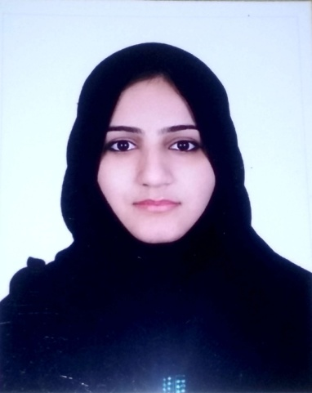

SABA

SABA.369267@2freemail.com

Objective

Seeking a challenging career oriented position where i can prove my proficiency and build my career.

Strengths

- Excellent ability to maintain high degree of customer service.
- Team player with excellent communication skills.
- Results driven and tactical planner with the proven ability to face challenges head on while exceeding organizational goals.
- Creative thinker and analytical problem-solver with demonstrated ability under the pressure of fast-paced, time-sensitive environments
- Enthusiastic participation in professional development and ongoing workplace learning.
- Ability of multitasking in a fast-paced environment, while maintaining an emphasis on quality.
- Ability to support queries via phone, fax and email.

Personal Detail’s

Nationality : Pakistani
Date of Birth : 11/09/1994
Sex : Female
Religion : Muslim
Marital status : Single
Visa Status : Residence
Education

HSSC- 1 ( PAKISTAN EDUCATION ACADEMY – DUBAI )

SECONDARY SCHOOL CERTIFICATE ( PAKISTAN EDUCATION ACADEMY - DUBAI )

Employment Summary

Bravura Events Management Mar 2011 – Sep 2012
Position (Receptionist)

My main responsibilities include:

- Hands on experience on events planning.
- Play role in designing and decorating events.
- Arrangements and welcome the guests.
- Providing excellent services to customers.

Etisalat Call Centre Oct2011 – April 2012
Position (Telephone Operator)

My main responsibilities include:

- Attending customer’s calls.
- Provide all information to them.
- Help them to solve their issues.
- General Inquiry services.

AL NASR LEISURELAND SUMMER CAMP june 2012 – August 2012
Position ( TEACHER)
july 2013 - September 2013

My main responsibilities include:

- Manage students details.
- Taking care of students.
- Coordinate with management.

HANEYA AL JANAHI ABAYA SHOP Dubai - March 2017 to Present
Position ( sales cum cashier)

My main responsibilities include:

- Taking orders
- Dealing with customers
- Preparing invoice
- Preparing all expenses and invoice on excel

Languages

- English
- Urdu

