SWEDA R  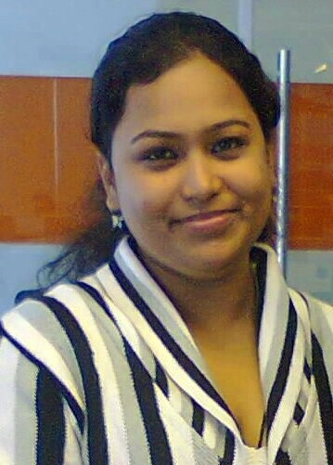  E-mail:  Sweda.369334@2freemail.com  Personal Data:  Date of Birth : 23rd December 1991  Sex : Female  Nationality : Indian  Marital Status : Married  Languages known:  (Mother Tongue underlined)  English, Malayalam, Hindi, Tamil.  Hobbies:  Listening to music, Dancing, Reading, Driving etc… | Objective  An organized professional with proven teaching, guidance and counseling skills. Possess a strong track record in testing scores and teaching effectively. Ability to be a team player and resolve problems and conflicts professionally. Have the ability to communicate complex information in a simple and entertaining manner. Looking to contribute my knowledge and skills in a school that offers a genuine opportunity for career progression.  Educational Qualifications  - M.A English Language & Literature from Kerala University, Kerala  (in the year 2015).  - B.A English (Hons.) from Delhi University, Delhi (In the year 2012).  - Senior Secondary School (10+2) from St. Mary’s Public School, Delhi under C.B.S.E board in the Year 2009.  - High School from St. Mary’s Public School, Delhi under C.B.S.E board in the Year 2007.  Computer Knowledge  - M.S office.  - Internet.  .  - Photoshop.  Personal Skill  - Comprehensive problem solving abilities.  - Organizing and managing capabilities.  - Willingness to learn and update myself with new methodologies & technologies.  - Positive attitude and team spirit.  - Good communication skill.  - Dedicated, focused, enthusiastic and hard working.  - Excellent with student handling.  - Expertise in teaching assistance.

Work Experience
A Result Oriented Professional With 1 Year Experience As Sr. Helpline Operator Cum Business Development Executive With AKZO NOBEL INDIA LTD. & 1yr Experience As a Middle School Teacher in SABARIGIRI RESIDENTIAL SCHOOL.
Specialization
Customer Service Operation and Business Development Executive
- Planning and preparing the entire customer care process.
- Monitoring the overall functioning of processes, identifying improvement areas and implementing adequate measures to maximize customer satisfaction level.
- Preparing MIS reports & other statements with a view to apprise management of the process operations and assist in critical decision-making process.
- Improving the productivity by eliminating discomfort and fatigue in the organization. Taking escalated calls, managing the floor and conducting the team performance reviews.
- Coordinating with various departments to resolve consumer complaints for effective communication between consumer and company.
- Managing service operations for rendering and achieving quality services; providing first line customer support by answering queries & resolving their issues.
Areas of Expertise
Customer Service Operation.
- Ensuring high quality services, resulting in consumer delight and optimum resource utilization for maximum service quality.
- Managing customer service operations & ensuring customer satisfaction by achieving performance assurance norms set by regulators.
- Formulating need-based plans / strategies in coordination with the top management; conducting deployment workshops and using various business tools for maximizing loyalty & satisfaction.

Currently Working As A Teacher In Sabarigiri Residential School.

- Maintain discipline in the classroom; methodically provide resource for lessons; simplify lesson plans in line with curriculum objectives and assist students to prepare for examination.
- Assess and look after 170+ students’ progress throughout the term and work closely with other staff to efficiently plan and coordinate work.
- Provide informative presentation to students regarding different areas of studies and ensure that all students fully comprehend all aspects of the curriculum.
- Meet with parents and school administration in a professional capacity to present information gathered during fact finding missions in an effort to improve student participation and elevate performance.
- Attended three workshops conducted by CBSE on CCE and one three-day workshop conducted by Lions Club on Skills for Adolescence.

I have more than 2 years experience as a English teacher

Declaration

I, Sweda , hereby declare that all the information furnished above is true to the best of my knowledge & belief

Place: Kollam, Kerala
Date: 06/03/2017 SWEDA

