CURRICULAM VITAE
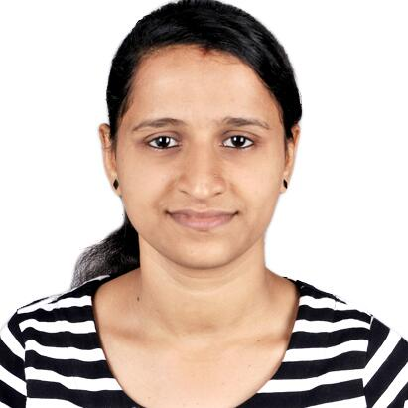

BHAVYA
Staff Nurse (B Sc
Valid MOH Licence
✉: bhavya.369368@2freemai.com

VISION AND OBJECTIVE

To bring out the best in me through every opportunity, to work in challenging and demanding atmosphere, always on a look out for a positive and bigger outlook, thrive on imagination and passion, sets levels and standards that exceed expectations, A Learner for life.

PROFESSIONAL QUALIFICATION

PB. B.Sc Nursing – Bangalore University
Diploma in Nursing & Midwifery - Bangalore Nursing Examination Board

Academic Qualification:

PUC - Mangalore University
SSLC – Karnataka Examination Board

OTHER IMPORTANT EXAMS PASSED:
BLS - American Heart association
Basic life support course (Blue code) conducted under Manipal University

LICENSE OR REGISTRTION:
NURSING REGISTRATION | REGISTRATION NUMBER | REG DATE /VALIDITY
KARNATAKA Nursing Council | Nurse: 0137176  Midwife: 0137176 | 24-06-2013

PROFESSIONAL EXPERIENCE
KMC Hospital – March 2013 to November 2016

Department in worked - Emergency department

DUTIES & RESPONSIBILITIES

Routine responsibilities

- Perform baseline assessment and provide stabilizing care to patients
- Assessment of patient needs, maintain patient records, update charts and prepare patients for transfer to respective departments
- Document details of all care activities performed as per hospital procedures
- Handle medico legal cases(MLC) as per hospital protocols and procedures
- Maintaining stock of supplies and timely indenting of pharmacy and general store items.
- Arrange sterile instruments and scopes for surgery.
- Maintaining an efficient standard of Aseptic Technique and well Developed Surgical Consciousness

Technical Skills

Expertise to handle the following equipments:

- Defibrillator / AED

- Electrocardiogram
- Cardiac monitors
- Arterial BP Monitor
- Pulse oximeter
- Glucometer
- Infusion pump
- Suction pump
Procedures performed/assisted
- Provide wholistic nursing Care.
- Attend Code Blue calls & perform BLS/ACLS as a member of CODE BLUE Team
- Operate defibrillator and AED

- Provide instantaneous care to the ill, injured or disabled.
- Establishment of Intravenous lines( jugular, brachial), IV catheter insertions
- Universal and contact precautions for MRSA, MSSA, HIV, H1N1
- Establishing central venous line and placing venous catheter
- Endotracheal intubation
- Fiber Optic Bronchoscopy
- Plural Tapping
- Plural Biopsy
- Urinary catheterization
- Bladder irrigation.
- Supra-Pubic Catheterization (SPC)
- Arterial Blood sampling; Venous blood sampling
- Cardiopulmonary resuscitation and defibrillation
- Electrocardiography with ECG interpretation
- Inter costal drainage (ICD) catheter insertion
- Airway Management – OPA insertion, oxygen administration
- Nasogastric tube insertion
- Splinting and cast application in trauma cases
- Administer medications (IV, IM, SC, ET)
- Collection of blood and other specimens( Sputum, ET aspirates, peripheral smears) for diagnostic investigations
- Develop nursing care plans according to patient needs
- Infection control and disinfection of articles
- Giving health education to the patient and relatives, encouraging the patients to cope up with the disease and maintaining good inter personal relationship with patients
- Discharge and transfer of patients
- Document details of all care activities performed.

EXTRA CURRICULAR ACTIVTIES:
- Participated and secured prizes in sports and cultural activities.
- Interests: Reading, Writing, Drawing, Listening music, adventure sports, etc.

PERSONAL PROFILE
Date of birth : 16 OCT 1989
Gender : Female
Nationality : Indian
Marital Status : Single
Languages : English, Hindi, Malayalam, Kannada, Tulu

