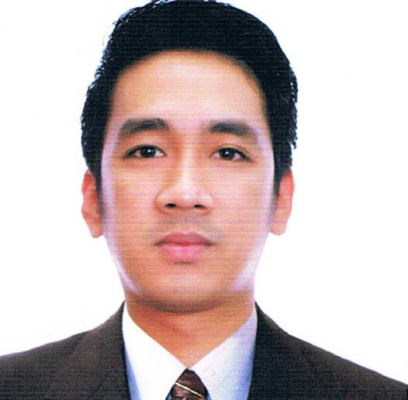
JOHN DARYL
Email: johndaryl.369390@2freemail.com

Objectives:

- A skilled medical professional seeking challenging task where I can be productive as a Nurse
- To grow experience that can make use of as a great opportunity in advancing professional career

Personal Data:

Date of Birth: August 5, 1987
Place of Birth: Quezon City
Age: 29
Sex: Male
Height: 5’5
Weight: 55kg
Citizenship: Filipino
Civil Status: Married

Special Skills
- Able to do Transthoracic echo to adult
- Able learn quickly and adapts easily.
- Nursing Care Management Skills
- Good Communication skills
- Good in interpersonal relationships both with co-workers and patients
- Acquired leadership and managements
- Can easily follow instruction regarding designated tasks
- Can work under pressure
- Computer literate(Microsoft word, Powerpoint, Internet)
Educational Attainment:
Haad Passer- April 30,2017

Prometric Passer- Kingdom of Saudi Arabia
Saudi Commission for Health Specialist #16-RN-0011870

Philippine Nursing Licensure Board Passer License # 0722852

Tertiary School: National College of Business and Arts (NCBA), 2006 – 2010
B. S. Nursing
Address: Brgy San JuanTaytay, Rizal, Philippines

Secondary School: Philippine Best Teacher Society(PBTS), 2000 -2004
Address: F. Cequena Street, Bo. MacamotBinangonan, Rizal Philippines

Primary School: Philippine Best Teacher Society (PBTS), 1999 – 2000
Address: F. Cequeña Street, Bo. MacamotBinangonan, Rizal Philippines

Professional Experience:

KING ABDUL AZIZ MEDICAL CITY
NATIONAL GUARD HEALTH AFFAIRS
Staff Nurse II Acute/Transitional Medical Ward Unit
October 2015 – Present

- Provides direct patient care utilizing the nursing process within established hospital, divisional and unit specific policies and procedures, standards and protocols.
- Demonstrate knowledge and clinical assessment skills appropriate to clinical area.
- Takes direct and appropriate action in urgent and emergency situations.
- Documents all assessment, interventions and other pertinent information in the patient’s health care record in a timely and ongoing manner
- Promotes continuity of patient care through oral and written communication.
- Demonstrate effective communication and collaboration skills when interacting with patient/families, other health care team members and staff of other departments
- Complies with hospital infection control and safety protocols.

ST. LUKES MEDICAL CENTER
Echocardiography Technologist
March 2015 – August 2015
- Perform Transthoracic echo to adult patient.

MARIKINA VALLEY MEDICAL CENTER
PulmonaryNurse
August 2012 –December 2014
- Performs respiratory therapy procedures according to department policies and physician’s orders;
- Review patient records for relevant medical history and Physician’s order prior to administering treatment;
- Performs patient assessment, prioritizes therapy and recommends changes in therapy, if indicated;
- Communicates patients information to relevant parties and updates patients records with timely, accurate and complete information;
- Administer aerosol therapy, percussion therapy, breathing exercises, and pulse oximetry;
- Perform arterial punctures and blood gas analysis;
- Assist in cardiopulmonary resuscitation;
- Sets up and monitors continuous ventilators;
- Sets up and monitor continuous oxygen, aerosol and humidity therapy;
- Perform pulmonary function test
- Read prescription, measure arterial blood gases and review patient information to assess patient condition
- Instructing patients how to use incentive spirometer, peak expiratory flow rate.
- Determine requirements for treatment, such as type, method and duration of therapy, precautions to be taken, and medication and dosages, compatible with physicians orders
- Work as part of a team of physicians, nurses and other health care professionals to manage patient care.

BINANGONAN MUNICIPAL HOSPITAL
Staff Nurse (Volunteer)
August 1 2011- February 2012
Binangonan, Rizal Philippines

- Renders professional nursing care to patients within an assigned unit of the hospital, in support of medical care as directed by medical staff and pursuant to the objectives and policies of the hospital.
- Performs nursing technique for the comfort and well-being of the patients.
- Prepares equipment and assists physician during treatment and examinations of patients.
- Administer prescribed medication orally and by injections; provides treatments using therapeutic equipment; observes patient’s reactions to medication and treatments; observes progress of intravenous infusions and subcutaneous infiltrations; changes or assist physicians in changing dressings and cleaning wounds or incisions; takes vital signs to detect deviations from normal and monitor progress of patients, following physicians order and approved plan of care.
- Performs intravenous insertions and giving intravenous medications
- Maintains medical records on nursing observations and action taken such as medication and treatments given, reactions, test, intake and output of liquid and solids, vital signs.
- Explains procedures and treatments ordered to obtain patients cooperation and allay apprehension.
- Rotates on all shifts and may be asked to rotate among various clinical and nursing service of the hospital.
- Maintain clean and orderly environment in the unit.

Professional Trainings/Seminars:
MARIKINA ST. VINCENT GENERAL HOSPITAL
Under the supervision of FAST MEDIC CORPORATION
CARDIO – PULMONARY NURSE
February 2012 – August 2012
- Set up and operates devices such as 7200 mechanical ventilators for adult and pedia, bi-pap machines, electrocardiogram(ECG) machines and Arterial Blood Gas machines, cardiac monitor and pulse oximeter.
- Perform pulmonary function test(PFT) and adjust equipment to obtain optimum result in therapy
- Taking and relay arterial blood gases result to physician
- Demonstrate respiratory procedure to trainees
- Read prescription, measure arterial blood gases, and review patient information to assess patient condition
- Work as part of a team of physician, nurses and other health care professionals to manage patient care
- Explain treatment procedures to patients to gain cooperation and allay fears.

Certificate of Training: Two Dimensional Echocardiography
September 30, 2014 – December 19, 2014
HB-Calleja Center for Cardiovascular Technology
Wilson St. San Juan Metro Manila

Basic Life Support: Cardiopulmonary Resuscitation (AHA Accredited)
June 22, 2016 - Valid until 2018
Based on 2010 American Heart Association Guidelines
Health Care Advantage Training Institute
#4 United St. Corner 1st St. Barangay Kapitolyo, Pasig City, Philippines

Advanced Cardiac Life Support (AHA Accredited)
March 24-25, 2014 - Valid until 2016
Based on 2010 American Heart Association Guidelines
Health Care Advantage Training Institute
#4 United St. Corner 1st St. Barangay Kapitolyo, Pasig City, Philippines

Basic Telemetry
March 14, 2014
Health Care Advantage Training Institute
#4 United St. Corner 1st St. Barangay Kapitolyo, Pasig City, Philippines

Competencies Completed:

Specialized Stroke Nursing Program
23-24 May 2016
Kingdom of Saudi Arabia
National Guard Health Affairs
King Abdulaziz Medical City

Chemotherapy Provider Course
19 June 2016
Kingdom of Saudi Arabia
National Guard Health Affairs
King Abdul Aziz Medical City

Central Venous Access Device Refresher Program
4 October 2016
Kingdom of Saudi Arabia
National Guard Health Affairs
King Abdul Aziz Medical City

Safe Blood Transfusion Practice
13 October 2016
Kingdom of Saudi Arabia
National Guard Health Affairs
King Abdul Aziz Medical City

Phlebotomy Venipuncture and Blood Sample Collection
10 December 2015
Kingdom of Saudi Arabia
National Guard Health Affairs
King Abdul Aziz Medical City

Nursing Procedure/Skills:

Tracheostomy Care
Suctioning
IV infusion including cannulation
Oxygen therapy
Chest tube management
Nasogastric and PEG (percutaneous endoscopic Gastrostomy) care
Urinary catheterization
Pre and post Bronchoscopic procedures, Nasogastric insertion
Pleural Tapping
Insertions CVP lines, Administration of Blood and Blood products
Chronic Mechanical Ventilation
Phlebotomy
Patient and Family education

