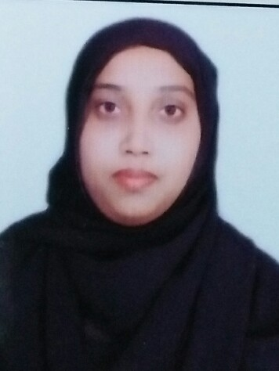 RESUME
Nikhath
Nikhath.369402@2freemail.com

CAREER OBJECTIVES
Seeking for the opportunities in the field of Sales & marketing/Business development where I can enhance & contribute my multi-tasking knowledge for the growth of the organisation & myself, always want to be a long term asset for the company.
Total 2 years of experience in Education sector till date.
Company Name and Profile | Job Description
Bright Institute of information Science  Student coordinator & Training Teacher  (Feb-2015 to March 2017)  2.3 Years’ Experience | • Develop and implement effective outreach programs targeted at providing effective services to students  • Ensure that all outreach programs are aimed at student retention and success  • Identify and resolve student concerns by acting as a mediator  • Handle incoming inquiries or student concerns  • Assist new students through admission processes  • Lead existing student through new program registration processes  • Prepare and deliver student orientation sessions  • Maintain documentation for outreach programs  • Participate in development activities aimed at student awareness and retention  • Prepare and deliver regular student activity and audit reports  • Provide information regarding distance learning programs  • Maintain student contact notes and records  • Track prospective students from query points to the registration processes  • Prepare for and participate in college or school events  • Prepare materials for seminars and workshops  • Monitor students with identified needs and complete appropriate paperwork  • Maintain student case reports and developmental histories  • Create and maintain liaison with teachers, counsellor and parents

Educational Qualifications
Course | Name of School/College | Year of Passing
M.Com | IDSG/Kuvempu University | 2016
BBM | Malnad Education Society | 2011
PUC | Malnad Education Society | 2008

Achievements & Awards in Corporate & personal
- Best lead generator
- Service excellence award
- Earned highest incentives among the team members

Professional Skills
- A dynamic & multitalented professional with exceptional Education Sector knowledge
- Proficient in Presentation & communication
- Proficient in Planning & forecasting
- Expert in implementing systematic work
- Good in utilization of all resources
Personal Traits
- Strong leadership & motivational Skill
- Ability to handle team & able to get the work done from others
- Ability to handle pressure
- Have a strong Self-confident & enthusiasm
- A quick learner & self-motivated person
- I am always an aggressive & smart worker

