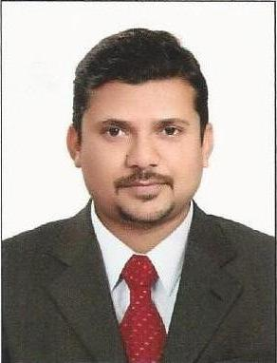
Resume

Name: Siraj
Siraj.369414@2freemail.com

OBJECTIVE: -

To prove myself in a hard and tough environment and leave no stone unturned in the line of my duty. I want to improve the organization and myself where I serve.

ACADEMIC QUALIFICATION: -

- Graduation from DDU Gorakhpur University 2011.
- Higher Secondary from U.P. Board in 2005.
- High School from U.P. Board in 2003.

PROFESSIONAL QUALIFICATION: -

- MBA in HR & Marketing from Subharti swami Vivekananda University Meerut in 2014.
- Diploma of Optometry from Shankar Hospital Gorakhpur in 2011.
- Certificate Course of Ophthalmic Technology from Joseph eye Hospital Tiruchirapalli in 2007. (Sponsored by Cristofel Blind Mission from Germany)
- Certificate course of Optical dispensing from Aravind Eye Hospital Madurai in 2009.
(Sponsored by Cristofel Blind Mission from Germany)

WORKING EXPERIENCE: -

- Worked as Ophthalmic technician in Fatima Hospital Gorakhpur, UP, India from 2007 to 2010.
- Worked as optometrist in Rishi eye care center, Gorakpur, UP, India from July 2011 to December 2011.
- Worked as optometrist in Titan eye plus, Gorakhpur, UP, India from December 2011 to July 2013.
- Currently working with Al Bashiq optics, Sarjah, UAE since July 2013 to till date as a Optometrist with store in charge responsibility.

EXTRA QUALIFICATION: -

- Diploma in Computer Software & Hardware

PERSONAL INFORMATION: -

Date of Birth : 10th Aug 1989
Marital Status : Unmarried
Gender : Male
Nationality : Indian
Language Known : Hindi, English, Tamil & Arabic

I hereby declare that the above information is correct to the best of my knowledge & belief.

