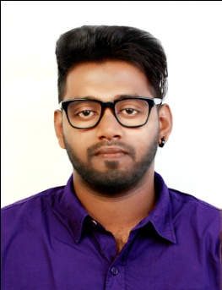
CURRICULAM VITAE

NIBIN

NIBIN.369424@2freemail.com

CARRIER OBJECTIVE

To acquire a challenging position in a reputed organization where I could use my good designing, hardworking and creative skills for the growth and good market position of the company.

EDUCATIONAL QUALIFICATIONS

- B-tech in Civil engineering from Calicut university, Nirmala College of Engineering with first class(62.4%) in 2015
- Higher secondary certificate(Plus Two) with first class(76%) in 2011 from Kerala educational board, Govt: samithy higher secondary school, Meladoor, Mala
- Secondary school living certificate(SSLC) with distinction(82%) in 2009 from Kerala educational board, H.C.C.E.M.H.S.School, Snehagiri, Mala

TECHNICAL SKILLS SET

Profient in:
- Quantity Surveying & Construction Management(FIDIC/CSI-2004 based institution), Governed under: VIBGYOR Educational Trust, Thrissur, Kerala, India
- AutoCAD Civil, Governed under: CADD Centre Training Services, Chalakudy, kerala, India
- 3ds Max & V-Ray, Governed under: CADD Centre Training Services, Chalakudy, kerala, India
- Revit Architecture, Governed under: CADD Centre Training Services, Chalakudy, kerala, India
- Primavera, Governed under: CADD Centre Training Services, Chalakudy, kerala, India. Certified by Synergy School of Business Skills, Chennai
- Ms Office

TECHNICAL SKILLS

- Dedicated
- Ability to quickly grasp new concepts
- Hard working
- Effective communication and interpersonal skills
- Team player

ACADEMIC PROJECT

- Planning, designing, analysis and estimation of a college hostel building accompanied with rain water harvesting system

WORK EXPERIENCE

From Jan-04 2016 to Dec-30 2016
- Worked as a Junior Engineer in CONCERN BUILDERS, Kerala, India
Job responsibilities
- Creating cad drawings
- Creating 3d images using 3ds max and Revit
- Quantity survey analysis
- Scheduling the work by using primavera

DECLARATION

All details that I have furnished above are true to the best of my knowledge and conscience bears witness to the same

