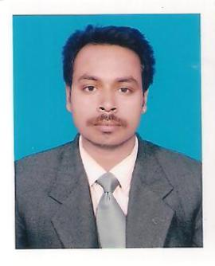
RESUME
APPLY FOR THE POST -GALLEY CLEANER

MR. SATYABRATA
EMAIL- ID- satyabrata.369470@2freemail.com

PERSONAL DETAILS
- NAME : SATYABRATA
- DATE OF BIRTH : 14TH APRIL 1987
- SEX : MALE
- NATIONALITY : INDIAN
- RELIGION : HINDUISM
- MARITAL STATUS : UNMARRIED
- LANGUAGE KNOWN : BENGALI ,ENGLISH ,HINDI ,ARIBIC

EDUCATION QUALIFICATION
- B.A PASS

PASSPORT DETAILS
- DATE OF ISSUE : 07/05/2015
- DATE OF EXPIRE : 06/05/2025
- PLACE OF ISSUE : KOLKATA

WORKING EXPERIANCE
NAME | POST | YEAR
HOTEL SAMRUDDHI RESTAURANT & BAR | ASST.CLEANER | 2014 TO 2014
HOTEL RAMGIRI INTERNATIONAL | CLEANER | 2015 TO 2016

DECLARATION
I HEREBY DECLARE THAT THE ABOVE INFORMATION GIVEN BY ME IS TRUE TO THE BEST
OF MY KNOWLEDGE.

DATE :
…………………………………………..
PLACE : Candidate Signature

