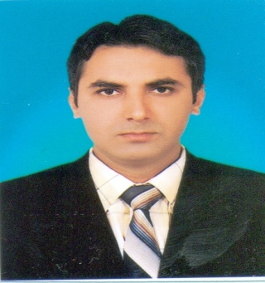
DR. JAI

General Practitioner

Email: jai.369480@2freemail.com

CAREER OBJECTIVE

My individual quest is to improve the human life by enabling the people to do more feel better and live longer as well to achieve personal and organizational goals by utilizing my knowledge, competencies and skills.

ACADEMIC QUALIFICATION:
MBBS
Liaquat University of Medical & Health Sciences 1999-2005
Jamshoro.Hydearbad.Paksitan 62.50%

SECONDARY SCHOOL CERTIFICATE (PRE_MEDICAL) 1997-1998
B.I.S.E Hyderabad. Pakistan 72.50%

HIGH SCHOOL CERTIFICATE 1995-1996
B.I.S.E Hyderabad. Pakistan 84.50%

MEDICAL REGISTRATION
1. U.A.E Ministry Of Health Exam cleared, Evaluation Certificate: 135199
4. Pakistan Medical & Dental Council NO: 51001-S
5. Data Flow Verification Verified

CLINIC EXPERIENCE:

I am working as a Senior Medical Officer at KUMAR Medical Clinic, Umerkot Sindh, Pakistan, Since January 01st 2008 to till date.
- Main duty is to receive the all kind of patients and immediate assessment & Evaluation followed by proper investigation and treatment plan on prioritize basis,
- Working on rotational basis with Medical, Surgical, Emergency, Pediatrics, Psychiatric, Orthopedics patients.
- Providing emergency care for medical emergencies to Trauma patient.
- Inpatient Admissions and follow up &Performed minor surgical procedures.
- Dealing sympathetically with sensitive circumstances

INTERNSHIP EXPERIENCES
- Completed one year internship, six month in Medicine & Allied and six months in Surgical & Allied from a period of 1st SEPT 2006 TO 31st AUG 2007.
- My basic responsibilities were to take proper history of the patients, a thorough physical examination, make differential diagnosis, formulate treatment plans & then discuss with post –graduate students, resident medical officers and consultants, attend patient subjective complaints, present topic to weekly meeting and cases to the consultant in every day ward round.

- Department of Gen. Surgery 1st Sep to 28th Feb. 2007 LMC Hospital Hyderabad
- Department of Gen.Medicine 1st March to 31st Aug 2007 LMC Hospital Hyderabad

JOB DESCRIPTION

- Carried out professional duties in surgical intensive care unit (SICU)
- General surgical ward, Medical ward
- Expert professional skills like ETT insertion, central/PICC Lines and chest tube insertion.
- Can deal all types of Ventilation. Participate in journal club meetings, case presentations ray conferences and CME program

Skills & Procedures:

- Expert in History taking, Physical examination, proper investigations followed by treatment & Proper referral,
- Accept Challenging & Flexible task with timing, can Work for long hours,
- Good interpersonal communication skills with Patients, Seniors & Colleagues,
- Cardiopulmonary resuscitation, Worked in surgical intensive care unit, Intravenous cannulation, Thoracic & abdominal paracentesis, Chest intubations, Venesection, Lumbar puncture etc

COMPUTER LITERACY:
- MS OFFICE 98/2000/XP/2007,
- Windows 2000/XP/Vista/2007,
- Power Point, SPSS & Internet Browsing

LAGUAGES:
- English, Urdu, Hindi, Sindhi, Punjabi.

PERSONAL INFORMATION:
RELIGION Hindu
NATIONALITY PAKISTANI
DATE OF BIRTH 3rd March 1981
MARITAL STATUS: MARRIED

REFERENCE:

Reference will be provided on request.

