 |  | Curriculum Vitae
 |  | Sunil
 | Dubai | E-Mail - sunil.369484@2freemail.com
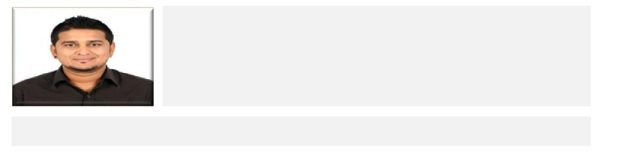
Professional Summary:

Very organized and capable Recruitment Specialist with excellent interpersonal skills and the ability to effectively identify screen and help the Hiring Mangers recruit viable applicants. I have excellent oral communication and writing skills and thorough knowledge of effective interview scheduling and screening strategies. I have a Bachelor's degree in Human Resources and more than four years of Recruitment Specialist experience.

Core Qualifications:

Excellent sourcing and screening skills for potential applicants Superb interpersonal skills

Excellent written and oral communication skills

Willingness to perform cold calling and other contact methods to attract quality employees

Strong ability in Managing Job Advertisements and Coordinating and Scheduling Interviews

Work History:

Recruitment Analyst 22 Nov 2012 to 31 Mar 2017

Accenture Bangalore, India

Working closely with the Recruitment Business Partners, Responsibilities include:

Sourcing top talent utilising sourcing techniques including, direct sourcing, internet mining, social networking and networking with referrals for leads

Developing performance profiles for positions to ensure only quality talent is presented to Recruitment Business Partners

Providing guidance to hiring managers on sourcing talent, trends, interviewing, HR best practices

Respond to Candidate and Hiring Manager queries and support RBPs in delivering high levels of service
Writing and Managing Job Advertisements and Scheduling Interviews

Phone screening candidate applications against defined criteria and making recommendations to RBP

Responsible for processing transactions within SLA complying with internal Quality parameters

Maintain manager and employee confidence by keeping human resources information confidential.

Ability to train and educate other people

Utilising Taleo to ensure that all recruitment activity is accurately tracked and offers to candidates are accurate when requested

Accenture

Service Management Analyst

Working with the Onshore and Offshore Service Delivery Leads, Responsibilities include:

Work with onshore personnel in forecasting the supply of work

Based on the forecasted supply, work with the offshore management team in resource planning

Calculate capacity utilization available in each therapeutic area and take necessary measures to move resources if required

Keep a track of production details on daily, monthly and yearly basis and report to management

Identify areas of concern and highlight to management

Discuss production status in management meetings and other forums like floor announcements

Track daily Dashboard details

Perform on-boarding and off-boarding activities, as and when required

Toyota Motor World Limited 20 Sept 2010 to 1 Oct 2012

Sales Advisor

Role and Responsibilities

Working within established guidelines, particularly with the brand Develop knowledge of the product range

Capture information, record it accurately and input it according to the company quality standards

Handle both incoming sales calls and make outgoing sales call

Assisting shoppers to find the goods and products they are looking for Giving advice and guidance on product selection to customers

Responsible dealing with customer complaints

Be involved in stock control and management

PERSONAL ATTRIBUTES

Good Judgmental and Problem solving skills when making decisions. Strong interpersonal and communication skills.

Detail oriented, dexterous in multi-task. Works effectively individually and with others as a team. Motivated and enthusiastic to learn new skills, industries and markets.

Ability to coach develops action plans, which maximizes performance and provide effective feedback.

Excellent customer service / support skills, ability to work well under pressure, professional demeanors and strong written and oral communication skills

Educational Qualification

Course | School/College | Year
SSLC | St Philomena’s School, Mysore | 2005
PUC (Commerce) | Vidhya Vikas Educational Trust, Mysore | 2007
Bachelors Degree (BBM) | St Philomena’s College, Mysore | 2010

Technical Skills: | Computer Knowledge, MS Excel, MS Word, MS PowerPoint
Personal Details
Date of Birth: | 06th Jan 1988 | Sex: Male
Visa Status: | Tourist Visa
Marital Status: | Single | Languages Known: English, Hindi
Hobbies: | Riding, Driving, Socializing, Chatting, Playing Cricket & more

Declaration: The above given information is correct to best of my knowledge. I would be happy to provide any further information you may require.

Yours Faithfully,

Sunil

