STELLA
STELLA.369486@2freemail.com 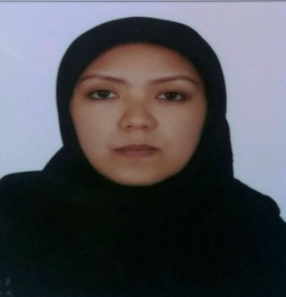

CURRICULUM VITAE
OBJECTIVE:
To be a part of your reputable company that will help me to enhance my skills, knowledge and abilities with my initiative and perseverance.
SPECIAL SKILLS:
- Good communication skills
- Complaint handling
- Excellent customer service
- Computer literacy
- Knowledge in MS Office (Word & Excel)
- Efficient and good natured
JOB EXPERIENCE:
Y-12 SALON
1st Floor Ritz Carlton Hotel DIFC Dubai UAE
Assistant Hairstylist / Receptionist
April 30, 2014 to present
JOB DISCRIPTION:
- Greet customers arriving at the salon and provide them with the information regarding salon services
- Answer telephone calls and provide information to callers
- Receive and sort daily mail/deliveries/couriers
- Schedule appointments and make follow up calls to clients
- Shampoo and condition guest’s hair for stylist
- Maintain salon appearance and cleanliness
- Promotes and sell services and product to the guest

LUXURIA NAIL SPA
J. Bocobo St. Malate Manila Philippines
Receptionist/ Senior therapist
April 28, 2013 - April 19,2014
- Deliver a variety of spa services (body treatment, massage, facial, waxing) in a safe and comfortable manner
- Maintain equipment and sample inventory of products
- Suggest and promote retail products or additional products
MARZAN PHARMACEUTICAL
Bangkal Makati Philippines
Pharmacy Assistant/Purchaser
March 4, 2006 May 25, 2012
- Must know how to read Doctors prescription
- Doing inventory
- Take in and handle out prescription
- Sell medicine over the counter / preparing and mixing medicine
EDUCATIONAL ATTAINMENT:
VOCATIONAL
Honorio MC Lopez Technical Institute (TESDA)
Cosmetology (NC2 Passer)
April 27, 2013
TERTIARY
Central Colleges of the Philippines
Bachelor of Science in Business Administration
Major in Management (undergraduate)
PERSONAL INFORMATION:
Date of birth: Febuary21, 1984
Place of birth: Bustos ,Bulacan
Nationality: Filipino
Civil Status: Single
Language Spoken: English / Tagalog

I hereby certify that the above information are true and correct to the best of my knowledge and belief.

