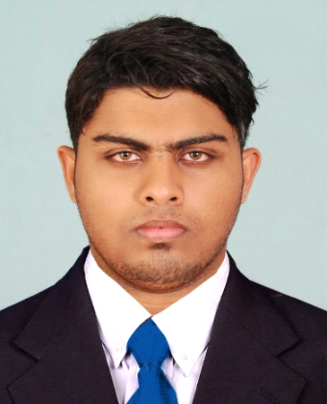 | REZVAN  rezvan.369498@2freemail.com

OBJECTIVE
Seeking a good position that will hone my technical skills and contribute towards the company's success and where opportunities to learn improve and innovate.

I take this opportunity to present my candidature to your esteemed organization for the suitable post. I enclose hereby my resume to show you a brief portfolio of my work for your kind perusal and conversation. I assure your good self that I would perform my duties to your fullest satisfaction and prove to be an assert to your esteemed organization if given a chance.
COMPUTER SKILLS:
- Working Knowledge in Ms-Office,
- Flash
- Tally
- photoshop

RECENT SALES EXPERIENCE

1 YEAR EXPERIENCE IN MARUTHI SUZUKI CAR SALES

PROFESSIONAL EXPERIENCE

2 YEAR MAINTENANCE EXPERIENCE IN AIRINDIA AS TECHNICIAN

1 YEAR TECHNICAL EXPERIENCE IN SHAURYA AERONAUTICS PVT LTD

EDUCATIONAL QUALIFICATION HIGHLIGHTS

Course | Year of Completion | Institution | Board/University | Percentage
Aircraft Maintenance Engineering  (Mechanical ) | 19.01.2013  (6month LA PE HA JE OJT  Completed) | Jawaharlal Aviation Institute  Ottapalam, palakkad,Kerala  India | DGCA | 85%
BCOM  MBA | 2010  2013 | SHRIDHAR UNIVERSITY  M.K UNIVERSITY | SHRIDHAR UNIVERSITY  M.K UNIVERSITY | 75%  STILL
PLUS TWO | 2009 | Farook higher secoundary school , kozhikode  Kerala,India | Kerala state board | 72%
TENTH | 2007 | NSS HSS,meenchandha calicut,kerala  India | CBSE | 85%

VISA STATUS

- CURRENTLY HAVING OWN VISA
- DRIVING LICENSE ON PROGRESS WAITING FOR FINAL TEST

COMPUTER SKILLS:

- Working Knowledge in
- Ms-Office,.
- Flash,
- Tally

PERSONAL PROFILE

Date of birth | : | 16/10/1991
Languages | : | English, Hindi, Malayalam, Tamil, Arabic (Read and write only).
Sex/Nationality | : | Male/ Indian
Religion | : | Islam/Muslim
Marital Status | : | Single
Professional | : | Team Work, Ability of smart working
Behavioral | : | - Well organized, Active, Confident & Flexible

DECLARATION:
I promise you conscientious and loyal service, sincere interest in my duties and responsibilities to the at most satisfaction of my superiors.
I, REZVAN do hereby declare that the details furnished above are true to the best of my knowledge and belief.

Place: AJMAN
Date :
(REZVAN)

