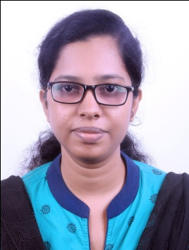
Blessy
Bachelor of Engineering (Civil)

Email ID: blessy.369519@2freemail.com

Profile Summary
- Around 4+ years of professional experience in site management, billing and estimation.
- Proficient in planning, co-ordination ,management and supervision of technical aspect of construction projects.
- Knowledge in various engineering documentation, drawings and reports.
- Excellent leadership, time management and decision making abilities.
- A keen Analyst and Team Player with thorough understanding of all aspects of the professional platform.
- Good communication, interpersonal skills and client -customer-friendly attitude.
Educational Qualifications

- Bachelor of Engineering(Civil Engineering),Annamalai University, Tamilnadu and secured 86%.
- 12th HSE, N S S High School, Kerala and secured 87%.
- 10th SSLC, N S S Girls High School, Kerala and secured 90%.

Certifications

- Certified in STAAD Pro software course.
- Diploma in Project Planning and Management using Primavera P6.
- Associate Member of Institute of Engineers,India

Skills

- AUTO CAD
- SAP R/3 ECC 6.04 EHP4(Purchase Order -Materials and services, Cash Journal, MIGO)
- Microsoft Office
PROJECT HANDLED

- Municipal Water Supply Project-Design,Supply,Laying,Testing,commissioning of clear water pumping main,construction of sump, culvert, lattice bridge and Railway pushthroug

Trainings

- Inplant training from PKM & Co ,Chennai
- Attended software training program by ADITI INFOTECH at Annamalai University Chidambaram for the software WMS, GMS, SMS, SURFER.
- Attended Entrepreneurship camp in Annamalai University

Experience

Organization: Shriram EPC Ltd,Egmore, Chennai. June2012 to till continuing
Position: Project Engineer

Responsibilities:
- Preparing estimate for the work.
- Liaising with company or project purchasing department to ensure that purchase orders adequately define the specified requirements.
- Planning the work and efficiently organizing the site facilities in order to meet agreed deadlines.
- Provides technical advice and quality control for all day to day activities of the construction site.
- Liaising with the project planning engineer, Client, Consultant, Sub contractors, Supervisors regarding construction programs.
- Preparation of Running Account bills on the basis of BOQ.
- Review the work on the basis of BOQ
- Checking materials and work in progress for compliance with specified requirements and ensures all safety requirements are meeting.
- Preparing cash flow statement for the project and analyzing the financial aspect of the project.
- Check the QAP reports before placing Purchase orders.
- Quality control in accordance with quality plans and inspection and test plans, all prepared by the project management team and by subcontractors.
- Checking drawings and quantities for accuracy of calculations.
- Preparing record drawings, technical reports, site diary.
- Supervising and counselling junior or trainee engineers.
- Evaluate and check the Quotation as well as stage billing of Sub contracts

Personal Details

Date of Birth : 12th September 1990
Marital Status : Married
Languages : English, Hindi, Malayalam &Tamil.
Nationality : Indian

