BABAR
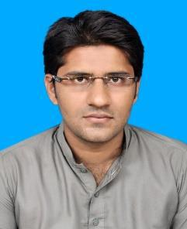
B.Sc. Civil Engineer

Dubai,UAE | Nationality | Pakistani
 | Visa Status | Visit Visa
Babar.369546@2freemail.com | Visa Validity | 26-July-17

Career objective

To work hard in a challenging and competitive environment as a civil engineer/Site Engineer where I can use my skills and Knowledge for the progress of the company and myself.

Experience

Elcon Associates (pvt) Limited Pakistan December 2015 - February 2016

Project:
1. Nayatel Office building (A Four Storey plaza in Faisalabad)

Worked as an assistant site engineer and assisted site management team for following
tasks:

- Monitoring and controlling manpower, materials and machines.
- Layout of the building.

- Studying technical drawings to calculate quantities of materials to be used.
- Worked as an assistant to consultant.
- Preparing daily progress report to evaluate efficiency of our execution team.
- Worked as surveyor to calculate levels of roofs, foundations and stairs etc.
- Preparing manpower deployment plan for completion of daily tasks.

National Highway Authority Pakistan December 2014 - August 2015

Graduation project:
  - Quality Control and Quality Assurance in Road Construction.

- Study of the quality control and assurance tests.

- Approval or rejection of the materials used according to the test results

- Recommendation of more economical methods used in Quality control and Quality assurance of roads.
Area of Expertise

• COSTING AND ESTIMATION • SURVEYING •SITE INSPECTION

Skills

• MS OFFICE • AUTOCAD • SAP

Academic Qualifications

Sr. | Certification / Degree | Institute / University | Specialization / Major | Cgpa/Marks | Passing Year
1 | B.Sc. | UET Lahore | Civil Engineering | 2.627/4 | 2015
2 | F.Sc. | BISE Multan | Pre- Engineering | 881/1100 | 2011
3 | SSC | BISE Multan | Science | 744/850 | 2008

Personal information

Marital Status | Single
Religion | Islam
Language Competency | English,Urdu,Punjabi

