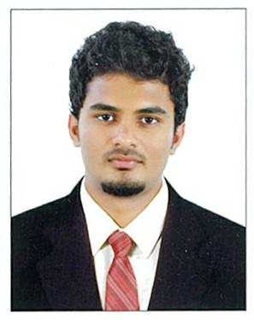
Faris

e-mail: faris.369599@2freemail.com

PERSONALPROFILE

Sex :Male

DateofBirth :21-02-1995

Nationality :Indian

Languagesknown:Malayalam,English

PROFESSIONALSUMMARY

WorkingasAnalyticalChemistatINTERFIELDLABORATORIES,Kochi (NABL&EICIndiaaccredited.)from16.07.2016tildate.

InvolvedintheanalysisoffoodandfoodproductsasperIS& ISOspecifications

WorkingasAnalyticalChemistatCOCHINTESTHOUSE,IRIMPANAM,Kochi (NABLaccredited.)from04.05.2015to13.07.2016.

InvolvedintheanalysisofwaterandwastewaterasperIS& ISOspecifications

EDUCATION

B.Sc.Chemistry,PetrochemicalsM.G.University(CGrade)

10-thGovtVHSSNorthEdappaly,March2009:68%(SSLC)

12-thGovtHSSNorthEdappaly,March2011:55%

WORKEXPERIENCE

FISHANDFISHERYPRODUCTS
Analysisofsulphurdioxide,Moisture,TVBN,Phosphorous,STPP,Salt
content,Sodiumcarbonate,Sodiumbicarbonate,citricacid,Formaldehydeetc.

FOODANDFOODPRODUCTS AnalysisSodium,Potassium,Calcium,Ash,Acid insolubleash,Cholesterol,Volatileoil,protien,Fatetc.

MILKANDDAIRYPRODUCTS
AnalysisofFat,Totalsolids,Titrableacidity,Protein,Saltcontent,
Moisture,Lossondrying,Ash,NonfatMilksoilds,etc.

SPICESANDCONDIMENTS
AnalysisofMoisture,Crudefibre,Piperine,Starch,Colourvalue,
Curcuminetc.

TEAANDCOFFEE
AnalysisofMoisture(Hotairoven&Vacuumoven),A.I.A,Ash,Iron
filing,Waterextract,Alkalinity,Watersolubleash,Waterinsolubleash,
Crudefibre,etc.

OIL&OILSEEDS
AnalysisofSaponificationvalue,Iodinevalue,Acidvalue,Peroxide
value,Moisture,Refractiveindex

AnalysisofNUTRITIONALFACTS(fat,protein,ash,moisture,

Carbohydrate,sugar,calcium,sodium,potasiumetc.)

InvolvedinthefolowinganalysisofwateraspervariousIS&ISO

specifications.[EfluentandDrinkingwater]

DRINKINGWATER
Aluminium,,Flouride,Nitrate,

Sulphate,Silica,Chromium,etc.usingUVVisibleSpectrophotometer,.Alkalinity,,Chloride, Hydrogenionconcentration[pH],Conductivity,Totalhardness,Calciumhardness,Magnesium.

EFFLUENTWATER
Totaldissolvedsolids,Totalsuspendedsolids,Totalsolids,Oil&Grease,
Dissolvedoxygen,COD&BOD,Phosphorous.

FamiliarInstruments

UV-VISSPECTROPHOTOMETER–SHIMADZU,VARIAN FLAMEPHOTOMETER–ELICO-CL378 AAS(AtomicAdsorptionSpectrometer)

DECLARATION

Iherebydeclarethattheabovestatementsmadearetrueandcorecttothebestofmy knowledgeandbelief.

FARIS

