CURRICULUM VITAE

KELVIN
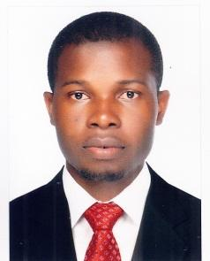
Email: kelowu.369610@2freemail.com

Dubai- U.A.E

Security Guard

Career Objective:

I am a professional and qualified security Guard with experience on the ground. A diligent and responsible worker, I work well in both static and mobile work modes. It is my hope to secure in-house employment with a well-established and respected security contractor.

Experience:

- Worked as a Security Guard at Ahodwo Estate Ghana for 2 years and 5 Months.
- Worked as Security Guard cum Receptionist at Mirdif Mall and Apartments, Dubai, for one year.

Duties & Responsibilities:

- Pro-actively ensuring the protection of merchandise, properties and assets.

- Control and monitor Password Access Control of entry and exit of tenants and visitors.

- Directing emergency vehicles and other traffic if a major incident occurs.

- Periodic patrolling inside and outside the mall.

- Responding to emergency alarms and situations as they arise.

- Accurately reporting all incidents to senior managers.

- Preventing and detecting offences on site.

- Producing written reports.

Competencies:

- Good observation skills.

- Aware of health and safety issues.

- Dealing with people politely but in a authoritative manner.

- Capability to monitor information feeds simultaneously from multiple sources.

- Having a professional approach to all routine tasks.

- Ability to communicate effectively at all levels.

- Experience of working on major events.

Personal:

- Well groomed and confident.

- Having a professional attitude.

- Possessing a friendly, approachable personality.

- Smart and presentable appearance.

- Willing to work shifts, morning, nights etc.

Personal Data:

 | Gender | : | Male
 | Date of Birth | : | 06-07-1986
 | Nationality | : | Ghana
 | Marital status | : | Single
 | Visa Status | : | Resident Visa
 | Language | : | English
 | DPS | : | Yes

Education:

 Bsc ( Psychology) University of Cape Coast, Ghana

Self Studies without Certificate (Online Studies Only)

- Cyber Security Fundamentals, Rochester Institute of Technology, USA

- eHealth, University of Twente, Netherlands.

Declaration:

I declare that the information given above is correct to the best of my knowledge. I’m looking forward to get an opportunity to work in your esteemed organization.

